NAS Provisioning Procedures

Revision History

|  |  |  |  |
| --- | --- | --- | --- |
| Name | Date | version | Summary of changes |
| Shrinath Kurdekar | 21-April-2017 | 0.1 | Initial – Separated Provisioning procedures from Main PCM |
| Shrinath Kurdekar | 25-April-2017 | 0.2 | Minor updates to post checks based on updates from Bharath for ESX allocation and Issue document |
| Shrinath Kurdekar | 30-June-2017 | 0.3 | Added Note on Cross Site Mounts for NFS exports procedures |
| Shrinath Kurdekar | 18-Aug-2017 | 0.4 | Added additional pre-requisite steps for key standards check like TRP load, Overcommit checks other key standard thresholds |
|  |  |  |  |
|  |  |  |  |
|  |  |  |  |

Review History

|  |  |  |  |  |
| --- | --- | --- | --- | --- |
| Reviewer Name | Doc Version Reviewed | Date Sent for review | Date Review Filed | Approved/Rejected  (with Reasons) |
| Storage-support | 0.2 | 26-April-2017 |  |  |
| Storage-Support | 0.3 | 30-June-2017 |  |  |
| Storage-Support, DCO-STO-SUPP-MGMT | 0.3 | 13-Sep-2017 |  |  |
|  |  |  |  |  |
|  |  |  |  |  |
|  |  |  |  |  |
|  |  |  |  |  |

1. It is the author’s responsibility to send this document out for review, making entries into columns 1-3
2. It is the reviewers’ responsibility to complete columns 4-5 and return the reviewed document to the author

Contents

About this document 4

1.1 Intended readership 4

1.2 In this guide 4

2 Storage Provisioning Procedures 5

2.1 Prerequisites when creating a new vFILER 5

2.2 Requesting a new IP for vfiler creation through Banana Tool 8

2.3 How to Provision Storage on 7-mode? 12

2.3.1 Create a new 7-mode vfiler 12

2.3.2 Create a LION (oracle on NFS) 7-mode allocation: 14

2.3.3 Create Primary/Secondary Archive log: 21

2.3.4 Create a WIP or WISP 7-mode allocation: 26

2.3.5 Create a non-LION NFS 7-mode allocation: 26

2.3.6 Create a 7-mode ESX allocation: 31

2.3.7 Create a CIFS 7-mode allocation: 35

2.3.8 Adding Space to existing 7-mode volume: 45

2.3.9 Adding Exports to existing volumes in 7-mode 49

2.4 How to Provision Storage on c-DOT? 51

2.4.1 Create a new c-DOT vserver: 51

2.4.2 NFS (LION Storage Provisioning) on c-DOT: 53

2.4.3 NFS (non-LION Storage Provisioning) on c-DOT: 53

2.4.4 ESX Storage Provisioning on c-DOT: 53

2.4.5 MySQL storage provisioning on c-DOT: 59

2.4.6 ISCSI storage provisioning for WISP on c-DOT: 59

2.4.7 Multiprotocol Storage Provisioning on c-DOT: 59

2.4.8 How to deploy NFS4 on c-DOT for MQ: 59

2.4.9 Add Hosts to Exports on c-DOT: 60

About this document

## Intended readership

This document is intended for use by Storage Support staff and also to limited usage by the Storage Altitude team at Thomson Reuters. This document outlines the process and procedures to be followed at the time of provisioning NAS Storage on 7-mode and c-DOT. Following the steps outlined in the document will ensure we have a consistent way of performing changes to our infrastructure and avoid the following:

* Misconfigurations in the environment resulting from a missed execution step
* Reduce risk/impact to the infrastructure
* Human Errors

It is imperative the process and steps outlined in here are expected to be followed by every individual in the team. Any deviation to the processes outlined here will need email approval from DCO-STO-SUPP-MGMT.

## In this guide

This document describes the NAS Storage provisioning procedures to be followed by Storage Support Staff at Thomson Reuters. This will include but not limited to

* 7-mode provisioning
* c-DOT provisioning
* Use of WFA workflows
* Standard provisioning methods through WFA
* Standard provisioning methods through Service Now Automation workflows

# Storage Provisioning Procedures

The following are links for the WFA service

* 1. [WFA CIS](http://167.68.250.87:27900/wfa/) – CIS instance
  2. [WFA CPS](http://167.68.246.65:27900/wfa/) – CPS instance

## Guidelines to be strictly followed for all Provisioning:

* 1. **WFA workflow and Service Now Automation Workflows should be used where applicable as documented in the PCM to avoid human errors.**
  2. **Ensure the Filer Aggregate utilization is below standard thresholds (standard thresholds are 75% for primary and 85% for backup filers) post migration. Ideally utilization should not exceed 65% for primary filers.**
  3. **Ensure the Aggregate Overcommit is below thresholds (200%) for all filers except Backup filers. Ideally this should be ~190% for all filers except backup filers.**
  4. **Ensure the performance checks are on the filers.** 
     1. Validate the physical Filer has sufficient room to accommodate the IOPS and throughout for new vfiler/volume. IOPS and throughput requirements should be available from requester or existing source vfiler if this is part of a migration.
     2. For 7-Mode, ensure the TRP load script (perfinfo.pl) along with NMC is checked to determine if the filer has room to accommodate the new request.
     3. For c-DOT use OPM/Grafana to review the performance on the target filer.
  5. **DO NOT combine Different BU data in the same vfiler. Escalate if we are closer to hitting vfiler limits.**
  6. **Review the performance on Source Vfiler/volume and ensure destination has room to accommodate this workload. For c-DOT ensure the IOPS are within standard 6k QOS values. If exceeding then review with D&E for exceptions.**
  7. **Ensure the vfiler count is as per Standard thresholds. Standard thresholds are <65 for 7-mode and 128 for c-DOT.**
  8. **Ensure volume counts are as per standards.**
  9. **Ensure the target Filer is from same Site, Module, Environment and Tier type and has same VLAN as requested.**

## Prerequisites when creating a new vFILER

* Check the vlan information for existing vfiler if this is for a migration event or vlan of the host that needs new vfiler. Please make sure the same vlan is available on the destination filer. Pay special care to any secure VLANs that exist in the environment like TAX secure ECOM, Clear Secure VLAN etc. To check the vlan:
  + Connect to <https://zipper.int.thomsonreuters.com/>
  + To find the VLAN of the source IP.

Enter the IP in the search expression and click on the below highlighted Icon

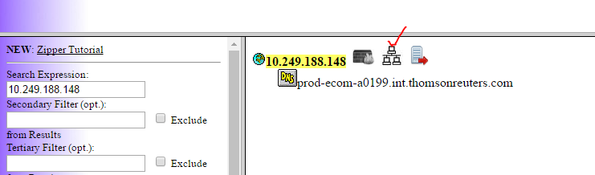

It will populate the VLAN, IP, Gateway and Netmask details.

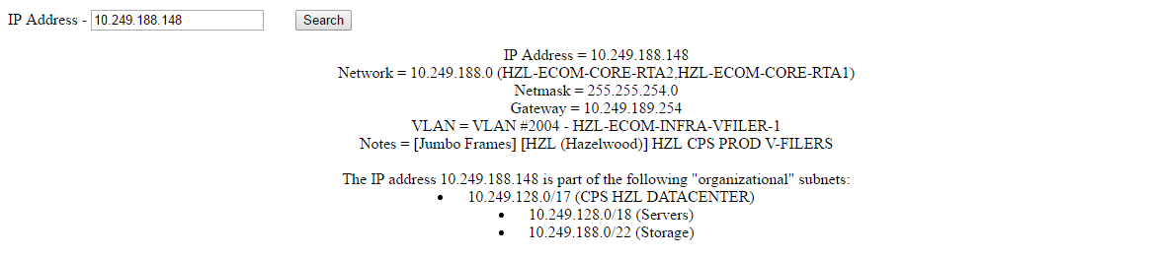

Above example shows a ECOM vlan#2004. We have ECOM, CORP, MGMT, COLO,SECURE ECOM Networks.

* Check the vfiler count on the physical filer. As per standards the maximum limit for # of vfilers is < 65 for 7-mode and 128 for c-DOT. Do not provision new vfiler if we are hitting this limit.
* Determine a vfiler name. Refer to section “Vfiler Naming” within the 7-mode Filer naming standards document here or “vserver Naming” within the c-DOT Filer naming standards document here
* Make sure you have the IOPS requirement for the vfiler being created. If migrating an existing vfiler this can be obtained from the NMC tool.
* Make sure the physical filer has sufficient storage capacity and sufficient room to accommodate the vfiler IOPS and throughput. This can be done through NMC and the TRP load check script. **Run the perfinfo script on the DFM server to validate if the filer has room for additional IOPS. If there is no room then make sure the aggregates are marked as FULL_PERF. This script is typically run by Delivery team for new builds and they will raise a ticket to storage-support to rename the aggregates. Support Engineers should also check this for emergency builds that do NOT go through delivery**

*How to check performance through NMC on 7-mode*

* + Download the NMC tool to your desktop from the Netapp Support site.

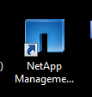

* + Use MGMT\M-account to login to the NMC console.

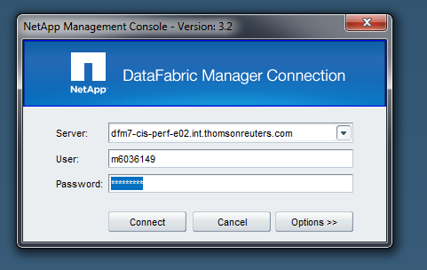

* + Enter the performance DFM name for the site where the filer is located.

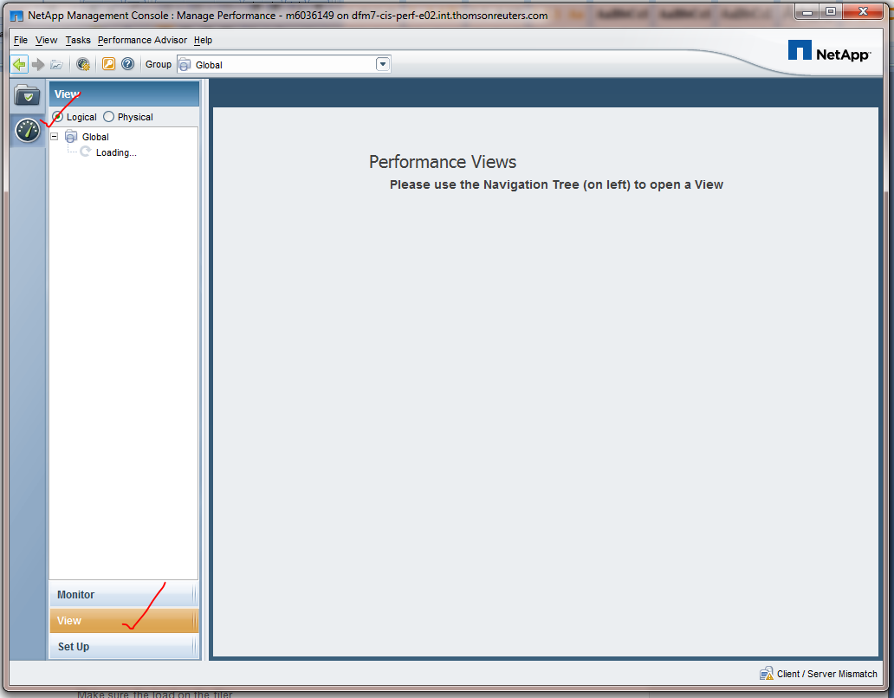

We have to select the above options to view the performance of the filer.

* + Select the filer and option TRP system summary view to verify the load and performance on the filer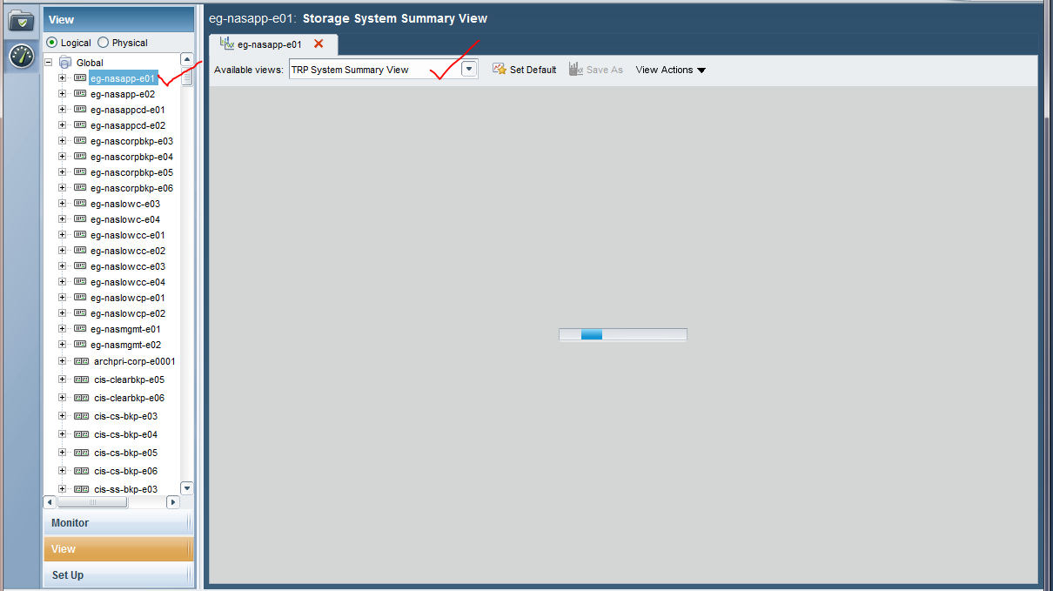
  + The following graphs will be shown. Please select 1 month duration to review filer performance.
  + 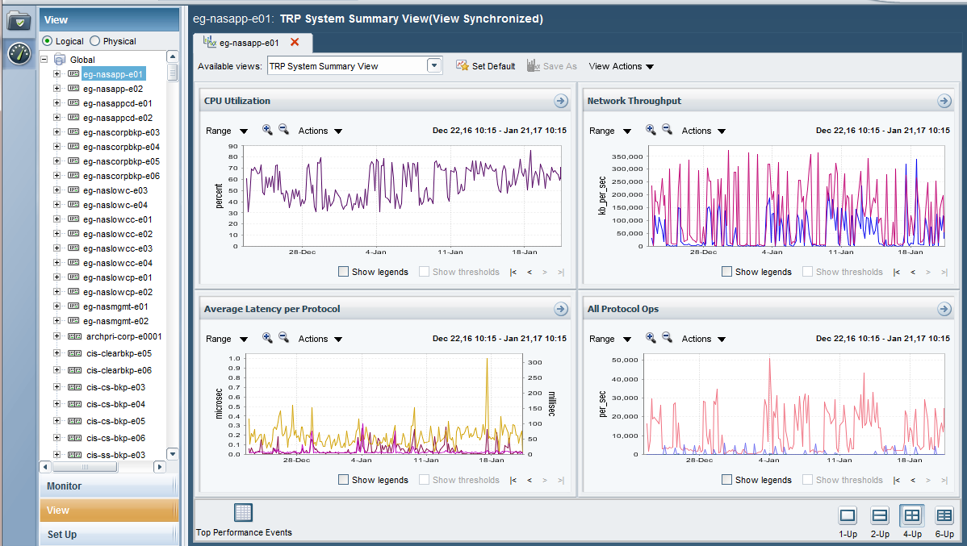
  + **Key things to check:**
* The CPU utilization should be average of 50 to 60%
* Read Latency should be < 20 milliseconds write should be < 5 milliseconds
* Refer Architecture standards section for 7-mode Filer IOPS limits. For c-DOT the threshold should be at 6000 IOPS as per the standard QOS policy
  + Check the current filer performance using systat. Make sure the disk are not busy and there are no back to back CP’s

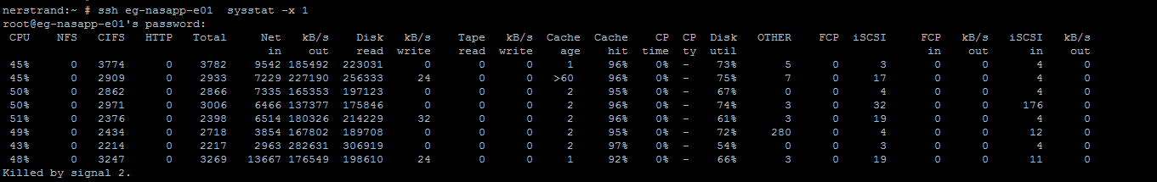

* + Check the Current CPU utilization:

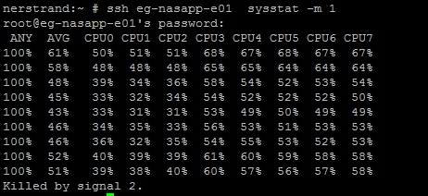

The average should be always below 60.

*How to check this on c-mode*

*<TBA>*

* Determine the aggregate to be used. This should not be more than 65% used for primary filers and more than 190% overcommit as our standards are 75% for primary filers and 200% overcommit threshold.

Ex: Below is the aggregate which we can use as the utilization is below threshold even after adding the new vfiler and required volumes and overcommit below thresholds.

*How to check this on 7-mode*

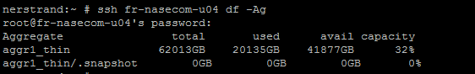

*How to check this on c-mode*

<TBA>

## Requesting a new IP for vfiler creation through Banana Tool

1. Launch the tool using a browser: <https://zipper.int.thomsonreuters.com/>
2. Once logged in you click on below BANANA ICON at the left top of the page.



1. You will see different options for both IP and DNS. Click on Request NEW under IP & Big/IP as shown below:

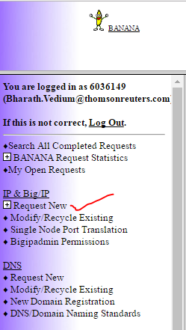

1. Click on the IP as high-lighted below

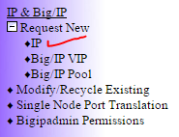

1. Enter the following details and click next to continue:
   1. *Device type:* Select Vfiler
   2. *Device name:* Enter new vfiler name which we will be creating
   3. *Owner:* Enter STORAGE-SUPPORT
   4. *Additional server info:* Enter the CR number for this change
   5. *Email Addresses to cc on this request:* Enter storage-support@thomsonreuters.com

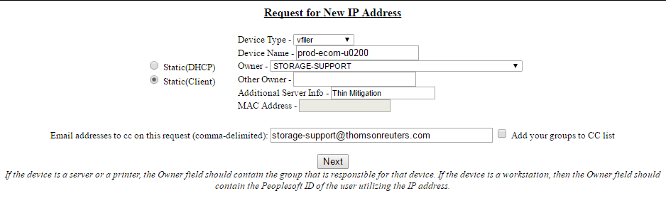

1. Here it will compare the new vfiler name which you had entered with the existing vfilers to avoid the conflicts. If there are no conflicts, click on continue else select a different vfiler name.



1. Enter the Vlan info in Vlan tab and hit enter.

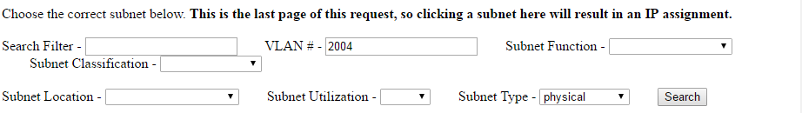

1. It will list all the vlan details and IPs. Select the subnet and it will assign an IP automatically.

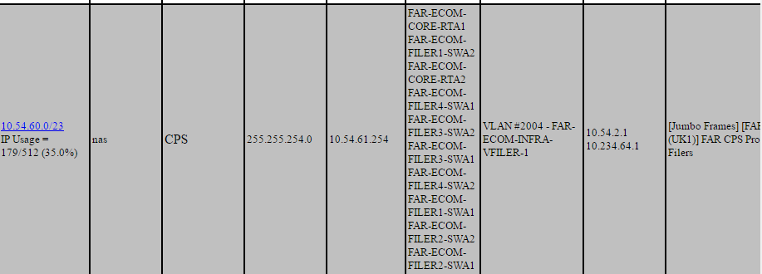

1. The IP request is now complete. An email confirmation will be sent from FLS-Network with the details

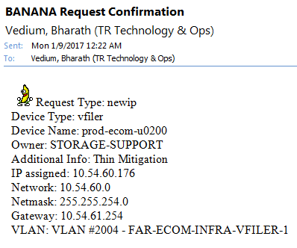

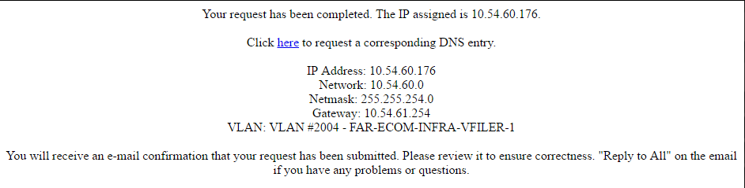

1. Next we need to add DNS to the vfiler. Click on the link “click here to request a corresponding DNS entry”.
2. Click on continue

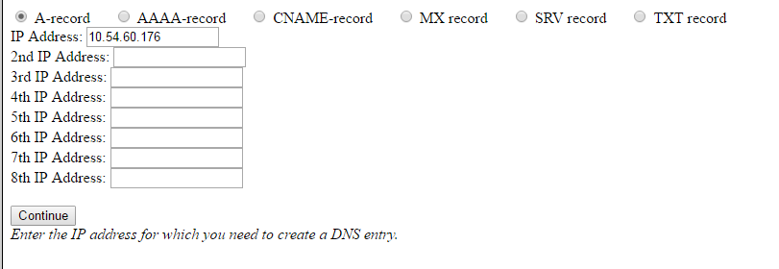

1. Enter the new vfiler name to complete the DNS request and hit continue.

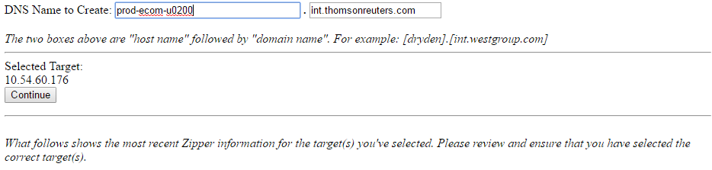

1. Submit the request. Enter the team DL once the request completed.

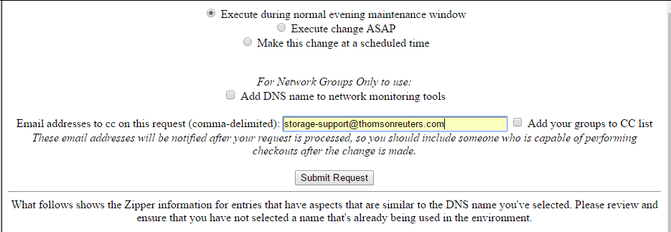

1. FLS-Network will send confirmation mail once the DNS request completed.

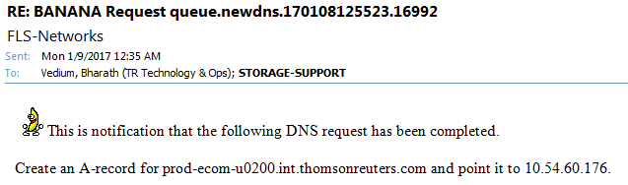

## How to Provision Storage on 7-mode?

### Create a new 7-mode vfiler

All new vfiler creation requests should go through the standard delivery process. Storage Support team should create a new vfiler only under the below circumstances:

* Tech refresh migrations
* Thin mitigation
* Migrations due to Performance Issues

*Pre-requisites:*

Review and follow the guidelines as outlined here:

Steps to create a new vfiler:

1. Complete the vfiler prerequisites and IP request as documented.
2. Next, proceed to vfiler creation using WFA. Note: **CLI should not be used.**

<http://167.68.250.87:27900/wfa/>   -- CIS

<http://167.68.246.65:27900/wfa/>    -- CPS

1. Login to the WFA using your MGMT\M-Account.

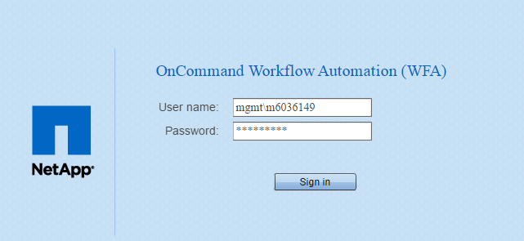

1. Select “7M vfiler only” to list available workflows. Select the appropriate workflow for NFS, CIFS or ISCSI. In this example we will build a NFS vfiler.

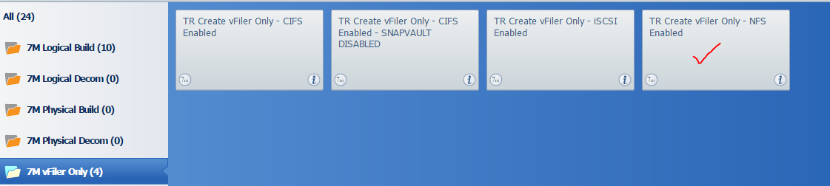

1. Enter all fields and use the Banana Request confirmation email for the IP/DNS details.

* *Array type:* Select primary filer if creating vfiler on the shared filer. Select Secondary Filer if creating vfiler on backup filer.
* *Primary Array:* We have to slect the filer in which we creating the vfiler. If we select the filer it will automatically populate available aggregates on the filer in Vfiler aggregate field.
* Pr*imary Vfiler:* Input the vfiler name which you are creating.
* *Vfiler Interface:* We have to select the Vlan in which we are tagging our Vfiler to the Vlan. Before selecting the Vlan we need to verify the VLAN exists on the filer.
* *Vifler IP and Vfiler Netmask:* Input these details from the banana Request which was raised.
* *Vfiler IPspace:* once the Vfiler interface is selected in the previous step it will automatically populate the IP space
* *DNS Environment:* Select based on filer location and module/environment. Do NOT select different site/module DNS
* *DNS Domain & DNS server :* Automatically populates *DNS domain* and *DNS server* once the DNS Environment is selected.

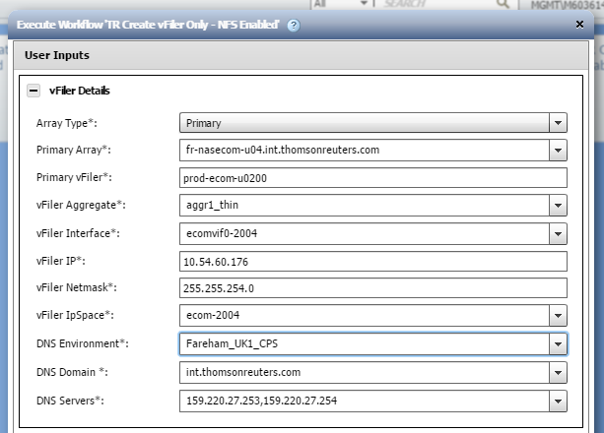

1. Execute the workflow.

If there is an error, “clear reservations” for that job and check the “user input” tab for errors. The most common reasons for failure are the vfiler/volume name is already in use, or entries in the user inputs reverted to their default values.

If the Workflow failed after the first task completes, you may need to manually offline and delete the new vserver before attempting to create it again.

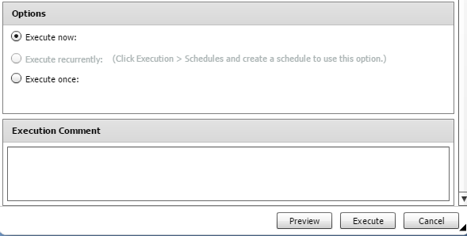

1. Complete the below post checks:
2. Ssh <physical filer> vfiler status –r <vfiler>

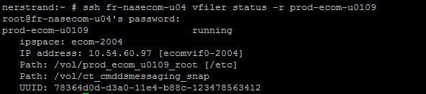

The above output will cover all the details of the vfiler. It has IP details,VLAN,IP space and the volume existing in the vfiler.

1. Ping the Vfiler from the DFMs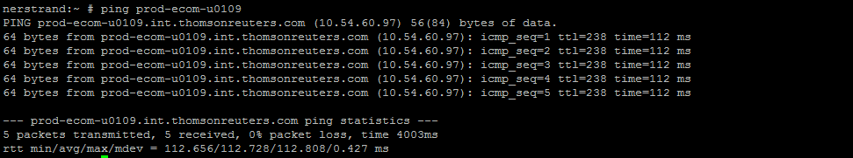

Ping the vfiler from the DFM to test the communication between the vfiler and the DFM server.

1. Perform nslookup to confirm IP to DNS and DNS to IP resolution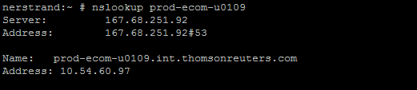
2. ssh < physical filer > rdfile /etc/rc (verify the vfiler settings in RC file on both nodes in the cluster. Below example is on one node only)

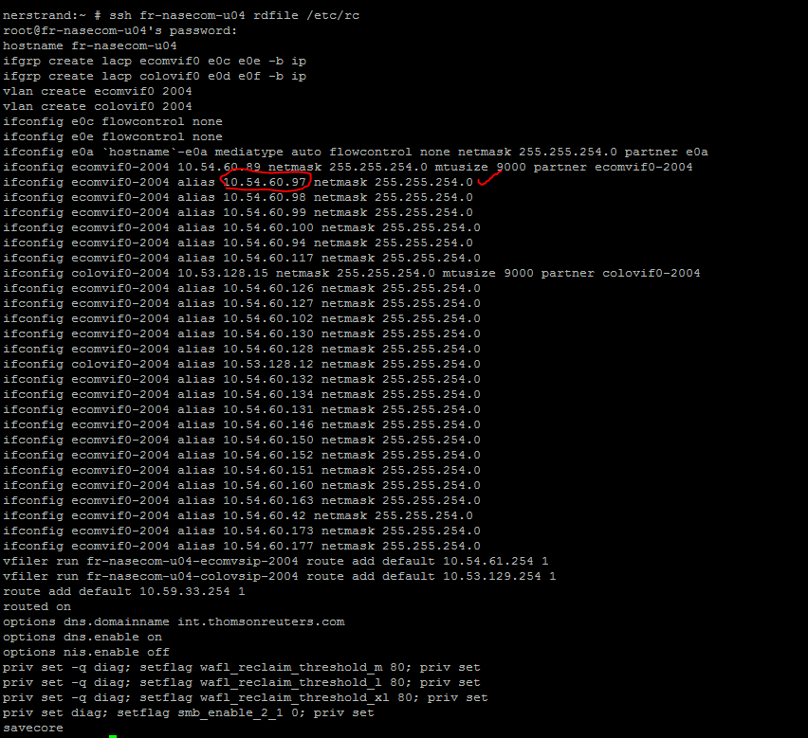

### Create a LION (oracle on NFS) 7-mode allocation:

All new LION vfiler/volume provisioning requests should go through the standard delivery process. Storage Support team should create a new vfiler only under the below circumstances:

* Tech refresh migrations
* Thin mitigation
* Migrations due to Performance Issues

*Pre-requisites:*

Below pre-checks are required before starting a LION allocation:

* Validate the vfiler details:
  1. Review and follow the guidelines as outlined here
  2. If this requires a new vfiler then, Complete the prerequisites and IP request as documented to obtain a vfiler name and (IP, DNS, Vlan) network details.
  3. If the request is to add space to existing vfiler, make sure you have the vfiler details. **DO NOT COMBINE DIFFERENT BU VOLUMES in SAME VFILER.**
* Check if the request is for CIS or CPS environment.
* As per standards three volumes need to be created n01, s01 and s01oraadmin. check if all these 3 volumes are specified in the request with relevant qtrees.
* Check you have information about hosts that need the volume exported and their FQDN/domain names are correct.
* Check if retention period has been specified for the snap volumes.

*Steps to complete the LION provisioning:*

1. Complete the prerequisites.
2. Next, proceed to vfiler creation using WFA. Note: **CLI should not be used.**

<http://167.68.250.87:27900/wfa/>   -- CIS

<http://167.68.246.65:27900/wfa/>    -- CPS

1. Login to the WFA using your MGMT\M-Account.



1. If the request is to create a volume per LION standards on an existing vfiler select the below template and go to step 7.

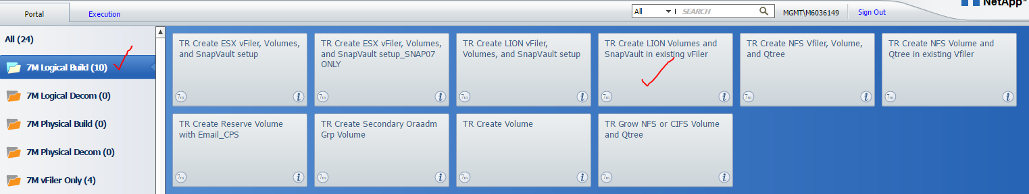

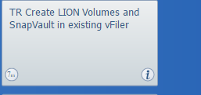

The only difference between the two templates “**TR create LION volumes and snapvault in existing Vfiler”** and “**TR Create LION vFiler, Volumes and snapvault”** is that when volumes are being created in an existing vfiler the existing vfiler details are input as shown below: 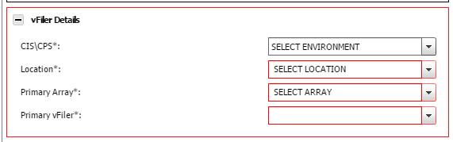

Rest of the inputs will be the same for both the templates.

1. If this is a complete new build that includes vfiler creation too, then choose the below template.

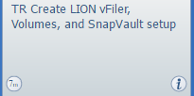

1. Enter the vfiler details using the Banana request email that was completed for requesting a new IP.

* *Array type:* Select primary filer if creating vfiler on the shared filer. Select Secondary Filer if creating vfiler on backup filer.
* *Primary Array:* We have to slect the filer in which we creating the vfiler. If we select the filer it will automatically populate available aggregates on the filer in Vfiler aggregate field.
* *Primary Vfiler:* Input the vfiler name which you are creating.
* *Vfiler Interface:* We have to select the Vlan in which we are tagging our Vfiler to the Vlan. Before selecting the Vlan we need to verify the VLAN exists on the filer.
* *Vifler IP and Vfiler Netmask:* Input these details from the banana Request which was raised.
* *Vfiler IPspace:* once the Vfiler interface is selected in the previous step it will automatically populate the IP space
* *DNS Environment:* Select based on filer location and module/environment. DO NOT select different site/module DNS.
* *DNS Domain & DNS server :* Automatically populates *DNS domain* and *DNS server* once the DNS Environment is selected.

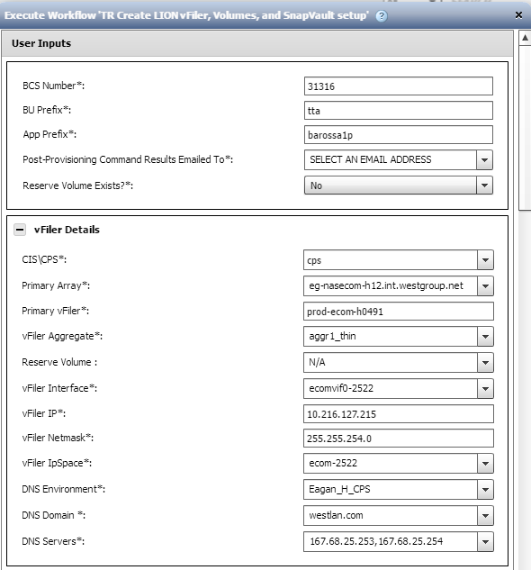

1. If, there is an existing vfiler given, proceed to enter the other details as below.

* Choose the aggr, enter the volume name, size and host names that need to be given RW/RO permissions as below.
* Check and uncheck the qtrees, which need to be created, as per the build request (Note: If you are adding volumes to existing vfiler select the relevant volumes/qtree that need to be created)

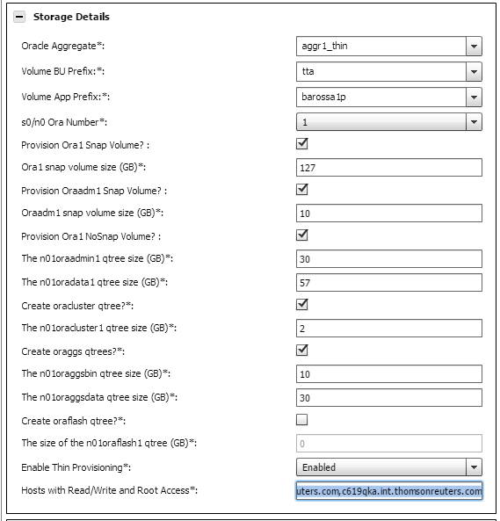

1. Enter the snapvault details for the snap volumes: Choose the appropriate backup vfiler/filer and retention period details.

*Key points to note while selecting the backup filer:*

* The Backup filer should be in the same site/datacenter as the source filer.
* Cross site backups should not be configured. (i.e Eagan E to F as this will traverse firewalls and could impact firewall traffic).
* Some sites may have multiple backup filers. Choose the correct one based on whether this is dedicated, ECOM or CORP.
  + Below are few examples for backup filers.
    - CORP backup filer: eg-nascorpbkp-e03
    - ECOM backup filer: ln-nasecombkp-d01
    - Dedicated backup filer: eg-nasappbk-f01
* For dedicated environments always use the dedicated Backup filer.
* For SECURE ECOM or COLO there are NO dedicated backup filers. Please select the filer that has VLAN tagged to support these modules.

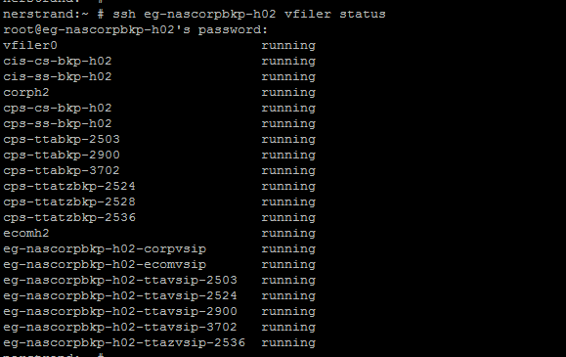

Above is an example of a backup filer which has vlans for ECOM, CORP and SECURE ECOM (TAX) environment. Select the appropriate vfiler.

1. If it is an s01oraadmin, choose the relevant group volume as below.

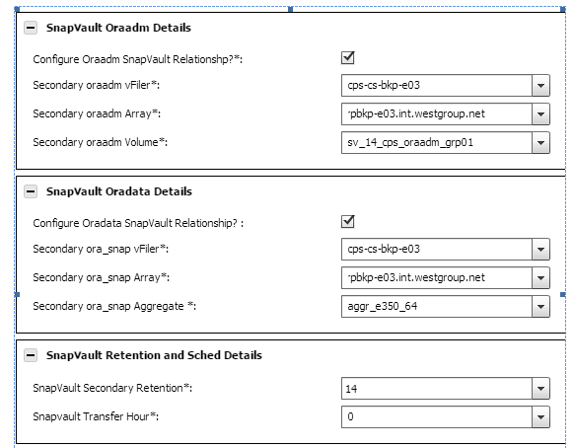

1. Skip the Primary and Secondary Archive log volume/qtree creation. Select NA for Primary Oraarch and DO NOT select checkbox for Secondary Oraarch as shown below:



1. After all the details, have been entered, click on preview. If the workflow goes green, click on execute.
2. If the workflow goes red, re-check if all the details mentioned are correct or not.

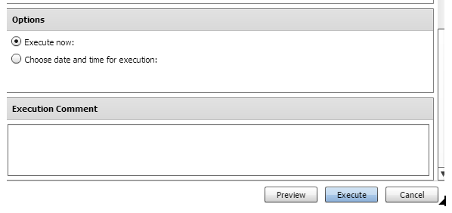

1. Once, the WFA has been executed completely, the output will be sent to your email ID.
2. Check the output and validate the results, if everything required has been created. Check if the volumes have been created as per the build with the appropriate sizes.

ssh <physical filer> vfiler run <vfiler> df -g

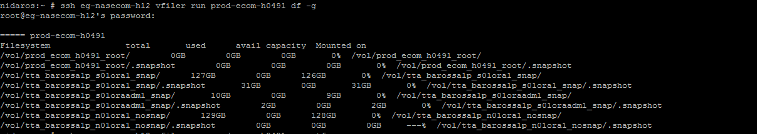

1. Verify if the server permissions are correct, with the *exportfs* command as above.

ssh <physical filer> vfiler run <vfiler> exportfs





1. Verify if the quotas have been created, with the *quota report* command as below.

ssh <physical filer> vfiler run <vfiler> exportfs

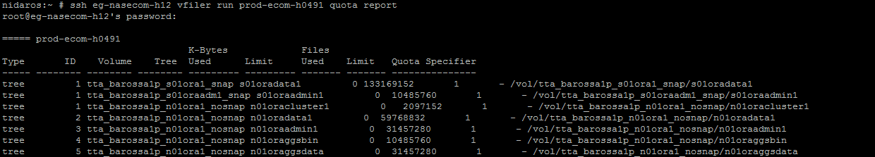

1. Verify if the snapvault has been created accordingly with the *snapvault status* command as below.

ssh <physical filer> vfiler run <vfiler> snapvault status

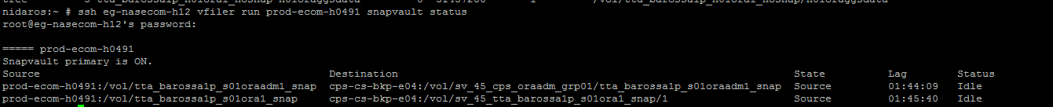

1. Next step is to provision the archive log volumes. Proceed to section for Archive log.
2. Request Platforms to Mount the volumes and close your tasks and CR.

### Create Primary/Secondary Archive log:

What are Archive logs?

Oracle Database lets you save filled groups of redo log files to one or more offline destinations, known collectively as the archived redo log, or more simply the archive log. The process of turning redo log files into archived redo log files is called archiving. Achieve logs mainly use for database at the time of restoration

Standards:

* As per the new standards the Arch volume will be created on CDOT filers. We have two arch volumes one is primary other one is secondary one. Please ensure you have read through the c-DOT Archive log standards
* Primary archive log is should be created on dedicated c-DOT archive log filers.
  + The dedicated Archive log c-DOT filer name will have **claa** in the cluster. Ex: eg-cis-**claa**-e01
  + The Vserver will have **oracle** name in the Vserver name. Ex: cis**oracle**-e0001
  + Refer to the c-DOT Filer naming standards for more information.
* Secondary archive log should be created on shared c-DOT filers where available. Note: This should not be on the same dedicated archive log filers as Primary Archive. In some locations this will be on 7-mode filers.
* For locations where dedicated c-DOT archive log filers are unavailable the primary and secondary should be split across different filer heads. Check existing setup and confirm with D&E/leads.
* For the Primary volume exports, it should be at volume level and the secondary volume exports should be at qtree level.

*Example Primary volume: cpsoracle-h0031:/ cb0289_trta_provision8provision_45_n01oraarch1_nosnap*

*Ex Secondary volume: cpsprod-h0080:/ infra_oraarchalt_cps_nosnap/ cb0289_45_trtaprovision8provision_n01oraarch2*

* Retention standard for archive logs is (7,14,30 & 45 days) and should be set as per the BU request

*Pre-requisites:*

Below pre-checks are required before starting Archive Log volume creation:

* Identify the archive log filers where the primary and secondary volumes will be created
* Identify the name of the existing vserver to be used.
* Check if the request is for CIS or CPS environment.
* Check you have information about hosts that need the volume exported and their FQDN/domain names are correct.
* Check if retention period has been specified for the snap volumes.
* Review and follow the guidelines as outlined here

*Steps to create the Archive log volume:*

1. Complete the prerequisites.
2. Next, proceed to vfiler creation using WFA. Note: **CLI should not be used.**

<http://167.68.250.87:27900/wfa/>   -- CIS

<http://167.68.246.65:27900/wfa/>    -- CPS

1. Login to the WFA using your MGMT\M-Account.



1. Use the below template to start creating the Volume.

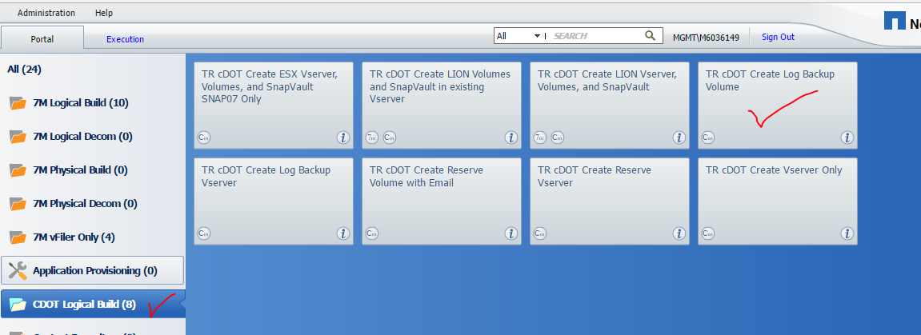

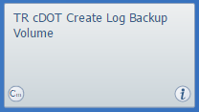

1. Provide the CR/ BCS number as well your email address to get the workflow commands.

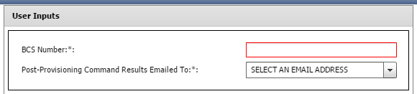

1. Enter the Cluster Details:

* CIS\CPS: choose the environment in which we are creating the volume either CPS\CIS.
* DNS Environment: Datacenter of the Archive log filer. This should always be the same site and Module DNS.
* Volume\DB type: chose NFS-Oracle for LION, CIFS-MSSQL for WISP and NFS-MySQL for MySQL
* Cluster: Choose the cluster in which we are creating the volume. It will automatically populate available selections for the fields Node, Vserver, Vserver lifs and the aggregate.
* Node: Select the node on the cluster where we are creating the vfiler.
* Vserver: select the vserver which we are creating the vfiler (Make sure you distribute the volumes across all available vservers)
* Vserver LIFs: Populated based on the selected Vserver
* Aggregate: Populated based on the selected node.

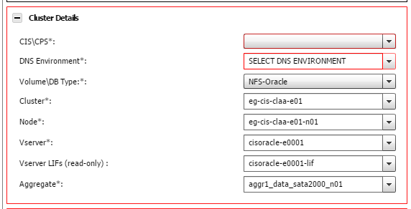

1. Enter the Volume details:

* Volume Prefix: Enter the volume prefix.
* Days of Retain logs: Archive log retention period (7/14/30/45 as per request)
* Volume size: 70000
* Oracle servers to export volume to: Input FQDN of servers which you are exporting
* Instance number: Number of instance running on the DB (provided by DB team)
* Compression start hour: Input after business hours (between 20:00 to 03:00 local DC time)
* DFM server: Provide the DFM server located in the same datacentre used to manage the filer.

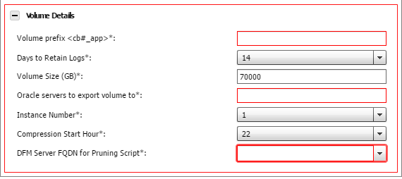

1. Execute the work flow

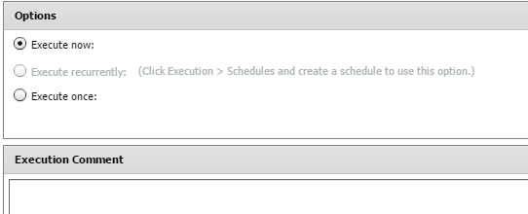

1. Now proceed to create the secondary log volume.
   1. As per the new standards, Secondary will be on shared cluster. We have dedicated volume for all the data centers for both the CPS and CIS environment. (one volume for CIS and one volume for CPS per data center).
   2. In secondary archive, we will not be creating new volumes. We will add the qtrees to the existing secondary archive volume.
   3. Steps involved are as below
      1. Identify the vfiler and volume for the corresponding CPS/CIS site from the link below:

<https://theshare.thomsonreuters.com/sites/ie/storage/Lists/Archive%20Log%20Locations1/Archive%20Log%20Locations.aspx>

* + 1. Create a new qtree.

#qtree create –vserver <vserver_name> -volume <Volume_name> -qtree <qtree_name>



* + 1. Create export policy.

Here the export policy should be the qtree name. We need to create the policyname as qtree name.



* + 1. Modify the qtree.

#qtree modify -vserver <vserver_name> -volume <volume_name> -qtree <qtree_name> - export-policy <policy_name>



* + 1. Export the server to the policy. Add servers to the default/export policy:

#export-policy rule create -vserver <vserver name> -policyname default –clientmatch <server name> -rorule sys –rwrule none –superuser none



#export-policy rule create -vserver <vserver name> -policyname <policy_name> –clientmatch <server name> -rorule sys –rwrule sys –superuser sys.



1. Complete Post Checks for Primary Archive volume:
2. Check the newly created volume:
3. Check the Export policy:

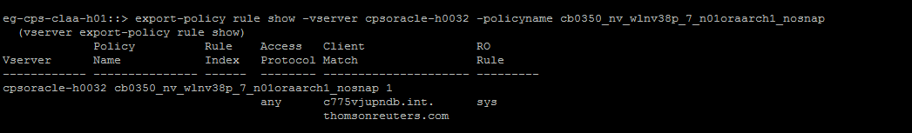

1. Snap settings: As it is no-snap volume the snapshot-policy should be none to avoid snap-overflow.
2. Step to validate archive log pruning is working?
3. Complete Post Checks for Secondary Archive destination:
   1. Verify the newly created qtree. Check the volume name and qtree name.

#qtree show –vserver <vserver_name> -volume <Volume_name> -qtree <qtree_name>

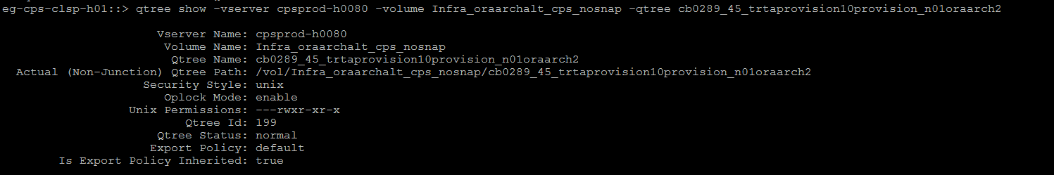

* 1. Verify the export-policy. Verify the policy name has been configured correctly or not.

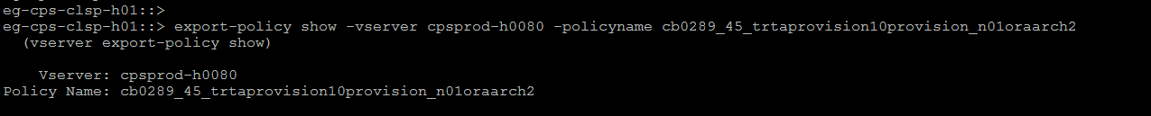

* 1. Verify the servers has been exported correctly.

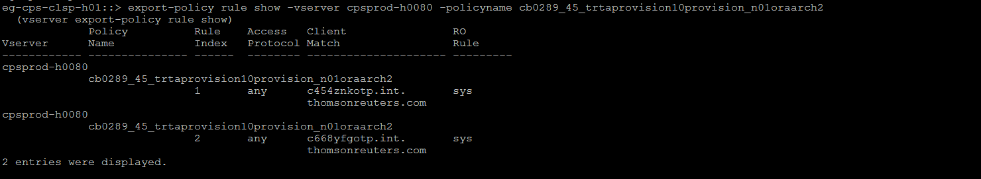

* 1. Check the servers have correct permission from storage end.

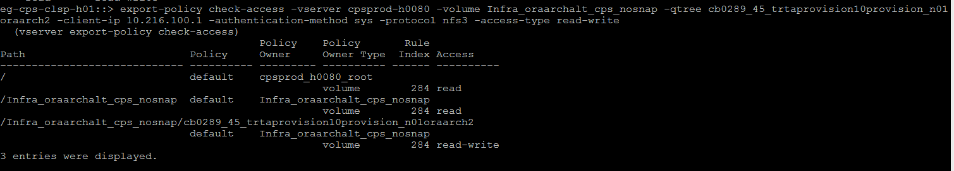

### Create a WIP or WISP 7-mode allocation:

<TBA in next version>

Review and follow the guidelines as outlined here

### Create a non-LION NFS 7-mode allocation:

All new NFS(non LION) vfiler/volume provisioning requests should go through the standard delivery process. Storage Support team should create a new NFS vfiler only under the below circumstances:

* Tech refresh migrations
* Thin mitigation
* Migration to another 7-mode filer due to Performance Issues

*Pre-requisites:*

Below pre-checks are required before starting a NFS (non LION) allocation:

* Review and follow the guidelines as outlined here
* Validate the vfiler details:

1. If this requires a new vfiler then, Complete the prerequisites and IP request as documented to obtain a vfiler name and (IP, DNS, Vlan) network details.
2. If the request is to add volume/qtree to existing vfiler , make sure you have the vfiler details. **DO NOT COMBINE DIFFERENT BU VOLUMES UNDER THE SAME VFILER.**

* Check if the request is for CIS or CPS environment.
* Check you have information about hosts that need the volume exported and their FQDN/domain names are correct.
* Check you have information about the volume and their sizes
* Check if retention period has been specified for the snap volumes.

*Steps to create new vfiler, volume/qtree for NFS (non-LION) provisioning:*

1. Complete the prerequisites.
2. Next, proceed to vfiler creation using WFA. Note: **CLI should not be used.**

<http://167.68.250.87:27900/wfa/>   -- CIS

<http://167.68.246.65:27900/wfa/>    -- CPS

1. Login to the WFA using your MGMT\M-Account.



1. If this request involves new vfiler and volume creation then Choose “TR Create NFS vfiler, volume and qtree” template, shown below.

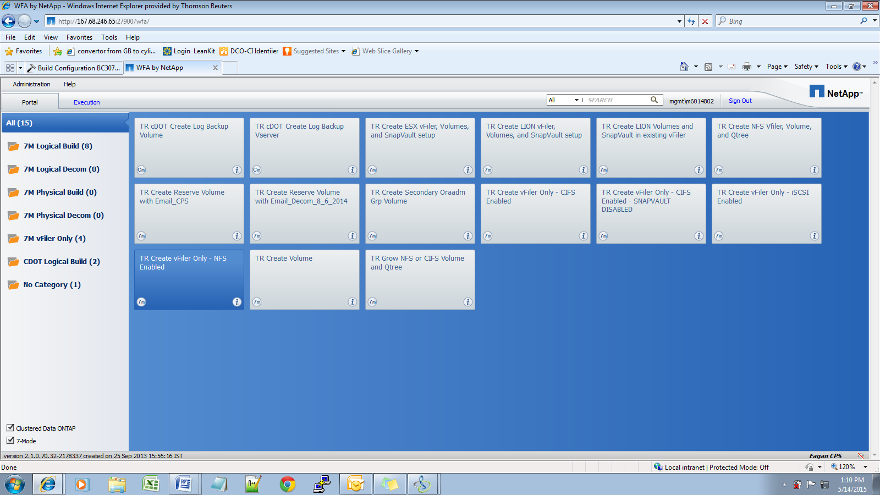

1. Enter all the necessary details, such as: Vfiler name, Vfiler IP, subnet,VLAN from the Banana request confirmation email

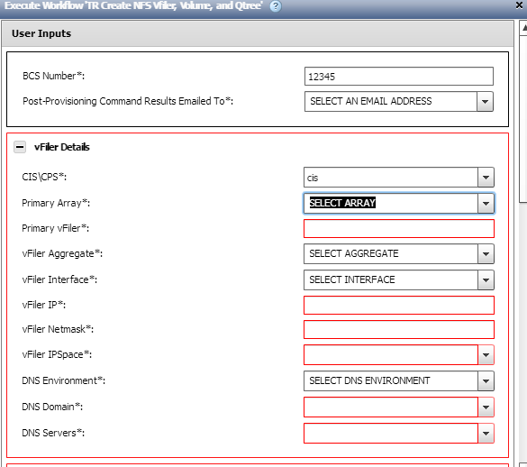

* NOTE: always double check the DNS environment.The DNS should be from same site and datacentre module.

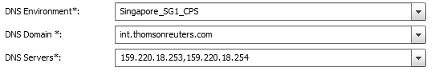

1. Enter the aggregate, volume/qtree details and volume size details as shown below.)

Note: Only add the chargeback and the application name (first two words) for volume details, do not add snap or nosnap suffix to the volume, as you can choose this option in the snapvault retention field shown further below.

*For example: cb0659_intergratedbatchqp*

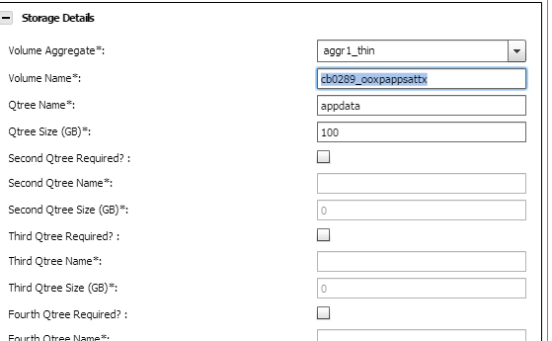

1. Add the RW/RO permissions for the hosts given in the build.

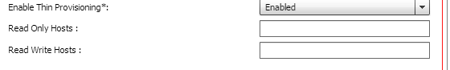

1. Next, choose if the volume is a nosnap or snap volume from the drop-down list (Snapvault retention needs to be selected for the snap volume) and the TRP load design matrix.

Note: TRP load design matrix can be fetched by mousing over this field in WFA. This provides the instruction to get the TRP. **The TRP load check should be completed as outlined in the pre-requisites.**

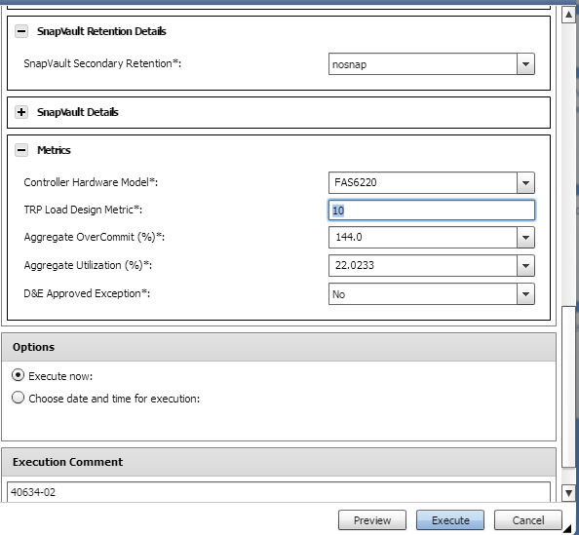

Aggregate overcommit and aggregate utilization are automatically populated. Once you mouseover these two fields you can find the threshold limits, beyond which we cannot provision the storage.

1. Click on preview and then execute the template accordingly.
2. Once the template is successfully executed an email with all the necessary outputs are sent.

*Steps to create new volume/qtree on existing NFS vfiler (non LION) provisioning:*

1. Complete the prerequisites.
2. Next, proceed to vfiler creation using WFA. Note: **CLI should not be used.**

<http://167.68.250.87:27900/wfa/>   -- CIS

<http://167.68.246.65:27900/wfa/>    -- CPS

1. Login to the WFA using your MGMT\M-Account.



1. Choose “TR Create NFS volume and qtree in existing vfiler” template, shown below.

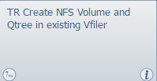

1. Enter the vfiler details and Storage details (new volume/qtree) as shown below

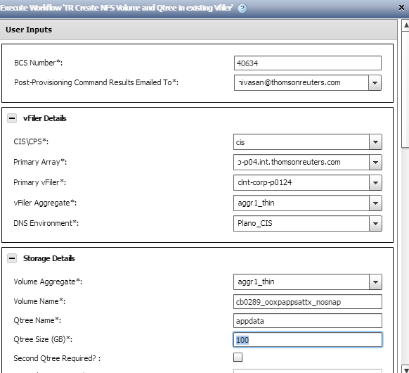

1. Next, choose if the volume is a nosnap or snap volume from the drop-down list (Snapvault retention needs to be selected for the snap volume) and the TRP load design matrix.

Note: TRP load design matrix can be fetched by mousing over this field in WFA. This provides the instruction to get the TRP.

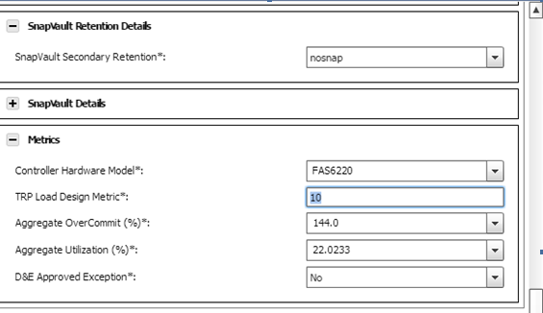

1. Click on preview and then execute the template accordingly.

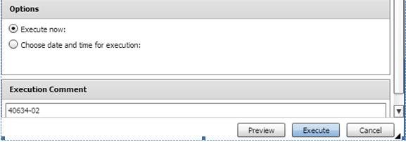

1. Once the template is successfully executed an email with all the necessary outputs are sent.

### Create a 7-mode ESX allocation:

*Pre-requisites:*

Below pre-checks are required before starting a ESX allocation:

* Review and follow the guidelines as outlined here
* Complete the prerequisites and IP request as documented to obtain a vfiler name and (IP, DNS, Vlan) network details.
* Check if the request is for CIS or CPS environment.
* Check you have information about hosts that need the volume exported and their FQDN/domain names are correct.
* Check if retention period has been specified for the snap volumes.

*Steps to complete the ESX provisioning:*

1. Complete the prerequisites.
2. Next, proceed to vfiler creation using WFA. Note: **CLI should not be used.**

<http://167.68.250.87:27900/wfa/>   -- CIS

<http://167.68.246.65:27900/wfa/>    -- CPS

1. Login to the WFA as below. We have to use MGMT\M-Account to login to the WFA.
2. Select the below highlighted one which will take care of (ESX- Vfiler / Volume/Snapvault creation)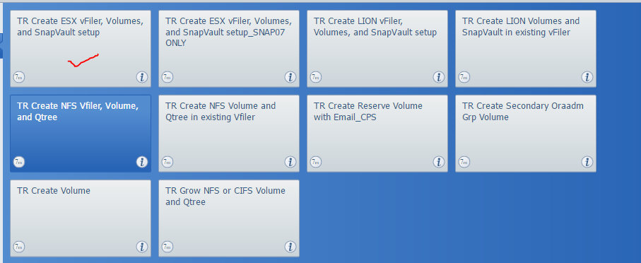
3. Please update correct BCS/CR# in BCS Number column. Input your email address to be notified via email from WFA upon Vfiler creation. The email contains all the command which are executed in background.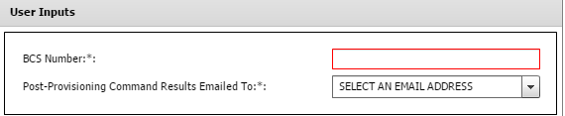
4. Next input the vfiler details. Please refer the email confirmation from FLS-Network for the Banana request to input the details

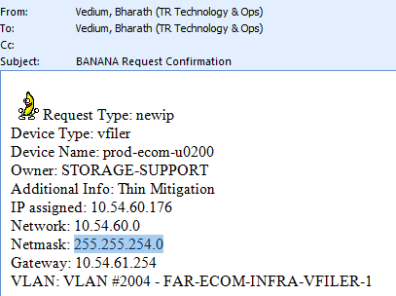

Update the below details:

* *CIS or CPS:* Input the correct environment as per the request
* *Primary Array:* We have to select the filer in which we creating the vfiler. If we select the filer it will automatically populate available aggregates on the filer in Vfiler aggregate field.
* *Primary Vfiler:* Input the vfiler name which you are creating.
* *Vfiler Aggregate:* Select aggregate that you identified during the prerequisites.
* *Vfiler Interface:* We have to select the Vlan in which we are tagging our Vfiler to the Vlan. Before selecting the Vlan we need to verify the VLAN exists on the filer.
* *Vifler IP and Vfiler Netmask:* Input these details from the banana Request which was raised.
* *Vfiler IPspace:* once the Vfiler interface is selected in the previous step it will automatically populate the IP space
* *DNS Environment:* Select based on filer location and module/environment. DO NOT select different site and module DNS.
* *DNS Domain & DNS server:* Automatically populates *DNS domain* and *DNS server* once the DNS Environment is selected.

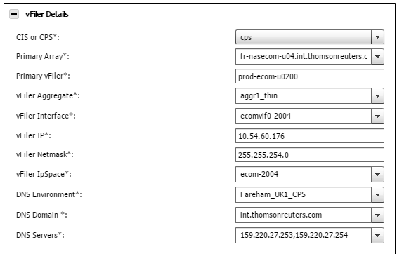

1. Next Input the volume details.
2. ESX Aggregate: Select the aggregate which you identified as part of pre-requisites and has space.
3. Provide the sizes of the volumes.
4. Enable Thin Provisioning: Select “Enabled” as Thin provisioning should be enabled
5. Host with Read Write and Root Access: Input the ESX hosts with FQDN that need access.
6. Primary De-Dupe hour: Dedupe (data duplication) should always be scheduled after local business hours. Select after 18:00.

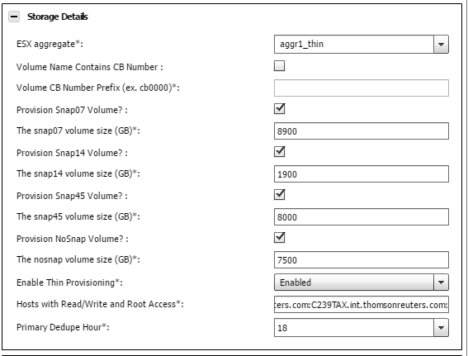

1. Next Input the Snapvault Backup configuration details:
   1. Are Snapvaults Required: Select yes if snapvault backup was requested.
   2. Secondary vFiler:
   3. Secondary Array: This is the physical filer where the vfiler is hosted. Ensure total volume count on the filer is <500.
   4. Secondary Aggregate: This will be the aggregate on the backup filer that has sufficient space. Ensure aggregate is <85% full.
   5. Primary Snapshot Hour: Primary snapshot hour should be after business hours during backup maintenance window (20:00 to 03:00 local DC time)
   6. Snapvault Transfer Hour: Snapvault transfer should be always one hour later than primary snapshot.

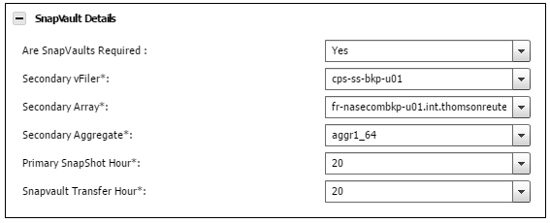

Note: The snapvault Transfer Hour should not be the same as Primary Snapshot Hour

1. Execute the workflow.



If there is an error, “clear reservations” for that job and check the “user input” tab for errors. The most common reasons for failure are the vfiler/volume name is already in use, or entries in the user inputs reverted to their default values.

If the Workflow failed after the first task completes, you may need to manually offline and delete the new vserver before attempting to create it again.

1. Complete Post checks and send email to dco-sto-supp-nas team:
   1. Check vfiler status using “ssh <physical filer> vfiler status –r <new vfiler>”
   2. Check volume status using “ssh <physical filer> vfiler run <new vfiler> df -h”
   3. Check host exports using “ssh <physical filer> vfiler run <new vfiler> exportfs”
   4. Check snap reserve configuration using “ssh <physical filer> vfiler run <new vfiler> snap reserve”
   5. Check snapvault configuration using “ssh <physical filer> vfiler run <new vfiler> snapvault status”
   6. Check snapshot schedule using “ssh <physical filer> vfiler run <new vfiler> df -h”

### Create a CIFS 7-mode allocation:

All new CIFS vfiler/volume provisioning requests should go through the standard delivery process. Storage Support team should create a new CIFS vfiler only under the below circumstances:

* Tech refresh migrations
* Thin mitigation
* Migration to another 7-mode filer due to Performance Issues

*Pre-requisites:*

Below pre-checks are required before starting a CIFS allocation:

* Review and follow the guidelines as outlined here
* Validate the vfiler details:

1. If this requires a new vfiler then, Complete the prerequisites and IP request as documented to obtain a vfiler name and (IP, DNS, Vlan) network details.
2. If the request is to add volume/qtree to existing vfiler, make sure you have the vfiler details. **DO NOT COMBINE VOLUMES FROM DIFFERENT BU.**

* Check if the request is for CIS or CPS environment.
* Check you have information about AD groups to which permissions should be added.
* Check you have information about the volume and their sizes .
* Check if retention period has been specified for the snap volumes.

*Steps to provision a new CIFS vfiler and volume/share:*

1. Complete the prerequisites.
2. Next, proceed to vfiler creation using WFA. Note: **CLI should not be used.**

<http://167.68.250.87:27900/wfa/>   -- CIS

<http://167.68.246.65:27900/wfa/>    -- CPS

1. Login to the WFA using your MGMT\M-Account.



1. Select the “7M vFiler Only” on the left pane. Once the available workflows are shown on the right pane, select the “TR Create vFiler Only – CIFS Enabled” for requests with snapvault backup and “TR Create vFiler Only – CIFS Enabled – SNAPVAULT DISABLED” for requests WITHOUT snapvault backup.

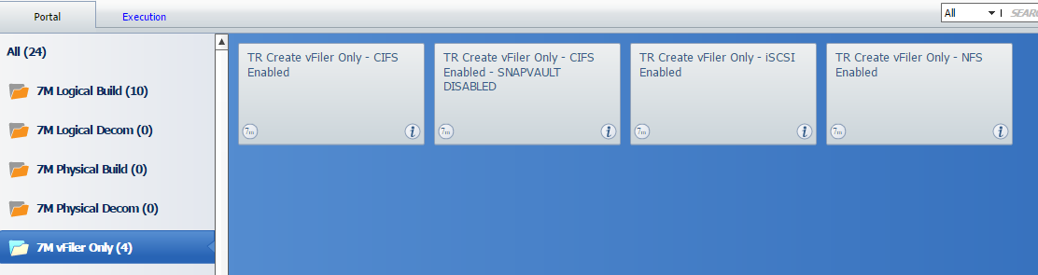

1. In this example, we have selected “TR Create vFiler Only – CIFS Enabled”. Next input the vfiler details. Please refer the email confirmation from FLS-Network for the Banana request to input the details

* *Primary Array:* We have to select the filer in which we creating the vfiler. If we select the filer it will automatically populate available aggregates on the filer in Vfiler aggregate field.
* *Primary Vfiler:* Input the vfiler name which you are creating.
* *Vfiler Aggregate:* Select aggregate that you identified during the prerequisites.
* *Vfiler Interface:* We have to select the Vlan in which we are tagging our Vfiler to the Vlan. Before selecting the Vlan we need to verify the VLAN exists on the filer.
* *Vifler IP and Vfiler Netmask:* Input these details from the banana Request which was raised.
* *Vfiler IPspace:* once the Vfiler interface is selected in the previous step it will automatically populate the IP space
* *DNS Environment:* Select based on filer location and module/environment. This should always be the same site and module DNS.
* *DNS Domain & DNS server:* Automatically populates *DNS domain* and *DNS server* once the DNS Environment is selected.

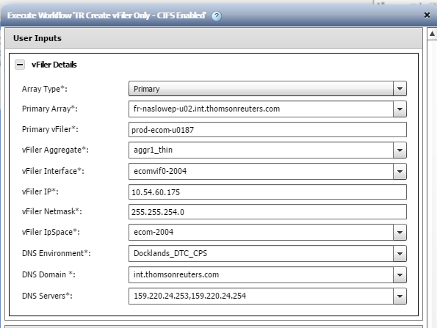

1. Execute the workflow.

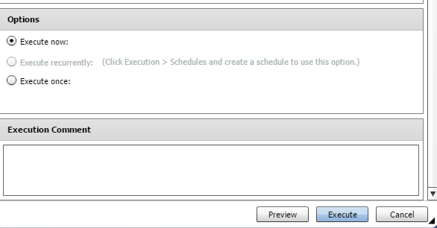

If there is an error, “clear reservations” for that job and check the “user input” tab for errors. The most common reasons for failure are the vfiler/volume name is already in use, or entries in the user inputs reverted to their default values.

If the Workflow failed after the first task completes, you may need to manually offline and delete the new vserver before attempting to create it again.

1. Perform post checks as outlined below to verify the new vfiler.
   1. Nslookup and ping the vfiler

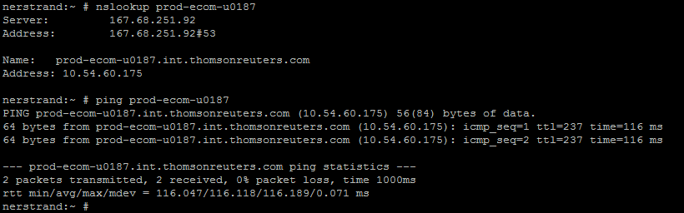

* 1. Check the vfiler status

#ssh <filer_name> vfiler status –a <vfiler_name>

* 1. Check the filer’s “/etc/rc” file for the vfiler entry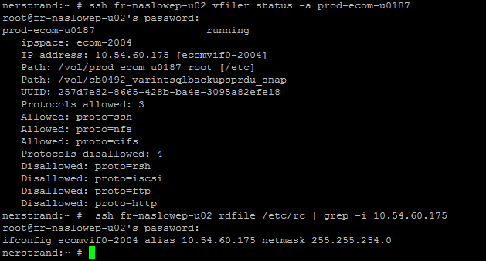
  2. Repeat Step c on partner node

1. Add the vfiler to Active Directory domain
   1. Login into Active Directory Management Server - 10.205.69.101

Login into our Laptop / Desktop 🡪 Start 🡪 Run 🡪 type “mstsc -v 10.205.69.101”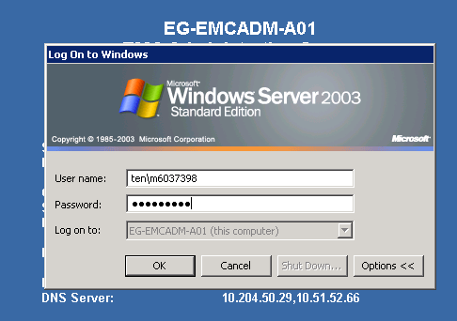

Login with our “TEN\M” credentials.

* 1. Procedure to add vfiler to “TLR” (depreciated) domain:
     1. After getting the server desktop click on Start 🡪 run 🡪 dsa.msc. Now, you will get your “Active Directory and Computers” dialogue box 🡪 Expand “TLR.Thomson.com 🡪 West-TLRCorp 🡪 Storage 🡪 NAS

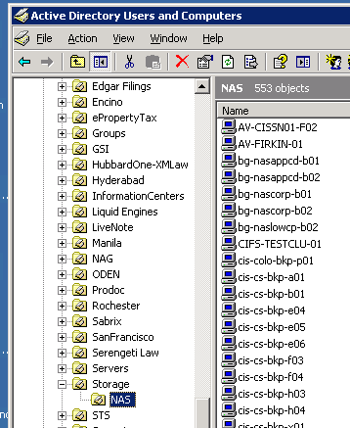

* + 1. Right click on NAS 🡪 new 🡪 computer 🡪 Give your Vfiler name🡪 next.

Note: A DNS (FQDN) name is not needed to add a vfiler or filer to AD (both ECOM and CORP). However, you should pre-create the computer account.

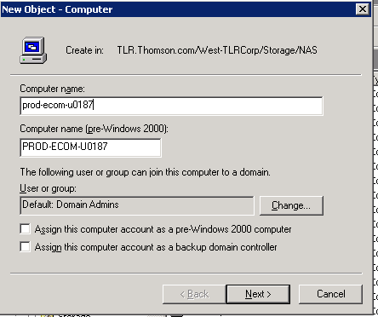

* + 1. After adding the VFiler to respective AD, need to setup the CIFS from the vfiler (CLI)
  1. Procedure to add vfiler to “TEN” (Standard) domain:
     1. After getting the server desktop click on Start 🡪 run 🡪 dsa.msc. Now, you will get your “Active Directory and Computers” dialogue box 🡪 Expand “ten.thomsonreuters.com” side menu 🡪 MSP01 🡪 Servers 🡪 NAS

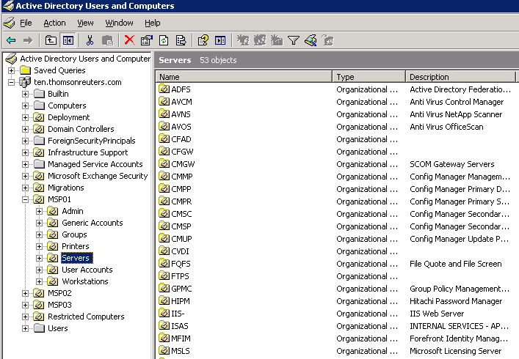

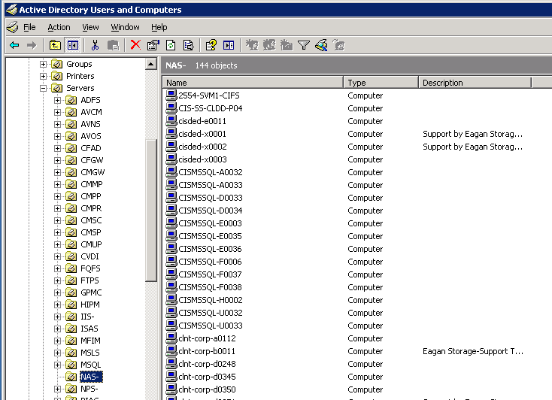

* + 1. Right click on NAS 🡪 new 🡪 computer 🡪 Give your VFiler or Filer name 🡪 next.

(Please follow same TLR procedure screen shot for “New Object – Computer” creation)

* + 1. After adding the VFiler to respective AD, need to setup the CIFS from the vfiler (CLI)
  1. Procedure to add to “MGMT” domain:
     1. Login to MGMT Citrix Jump box using your MGMT\m account

<https://eg.mgmtcitrix.thomsonreuters.com/Citrix/XenApp/auth/login.aspx?CTX_FromLoggedoutPage=1>

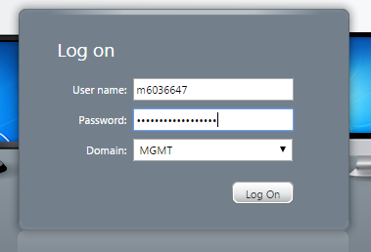

* + 1. In Applications menu, select the “Active Directory Users and Computers” and get the dialogue box.

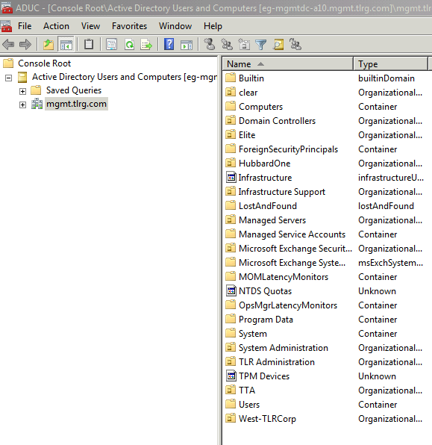

* + 1. Now, you will get your “Active Directory User and Computers “ 🡪 Expand the “mgmt.tlrg.com” 🡪 West-TLRCorp 🡪 Storage 🡪 NAS
    2. Right click on NAS 🡪 new 🡪 computer 🡪 Give your vfiler name 🡪 next

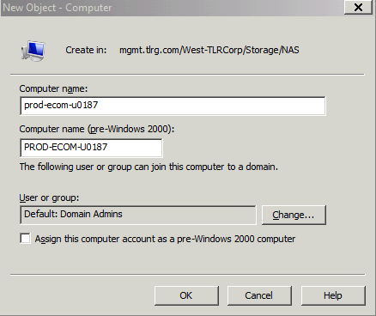

* + 1. After adding the vfiler to respective AD, need to setup the CIFS from the vfiler (CLI), please follow the steps as above mentioned.

1. Login to the physical filer to complete the CIFS setup

ssh <physical filer>

<physical filer>>vfiler context <vfiler name>

<vfiler name>@<physical filer>>cifs setup

Example:

ssh fr-naslowep-u02

fr-naslowep-u02 >vfiler context prod-ecom-u0187

prod-ecom-u0187@fr-naslowep-u02>cifs setup

1. Input the details as requested:

This process will enable CIFS access to the filer from a Windows(R) system.

Use "?" for help at any prompt and Ctrl-C to exit without committing changes.

Your filer does not have WINS configured and is visible only to

clients on the same subnet.

🡪**Do you want to make the system visible via WINS?:enter**

A filer can be configured for multiprotocol access, or as an NTFS-only

filer. Since multiple protocols are currently licensed on this filer,

we recommend that you configure this filer as a multiprotocol filer

(1) Multiprotocol filer – A logical partition of N/W and storage resources in Data ONTAP.

(2) NTFS-only filer – A logical partition for Windows only.

Which option/type of VFiler required, please select the respective

number.

🡪**Selection (1-2)? [1]:enter**

The default name for this CIFS server is 'PROD-ECOM-U0187'.

🡪**Would you like to change this name? [n]:enter**

Data ONTAP CIFS services support four styles of user authentication.

Choose the one from the list below that best suits your situation.

(1) Active Directory domain authentication (Active Directory domains only)

(2) Windows NT 4 domain authentication (Windows NT or Active Directory domains)

(3) Windows Workgroup authentication using the filer's local user accounts

(4) /etc/passwd and/or NIS/LDAP authentication

🡪**Selection (1-4)? [1]:enter**

🡪**What is the name of the Active Directory domain? [int.westgroup.com]**: **int.thomsonreuters.com** *<- The AD domain where the vfiler is being created*

In order to create an Active Directory machine account for the filer,

you must supply the name and password of a Windows account with

sufficient privileges to add computers to the ECOMQC.TLRG.COM domain..

🡪**Enter the name of the Windows user [Administrator@TENADLDAP.INT.THOMSONREUTERS.COM**]: **mgmt\mxxxxx** *🡨 your mgmt\m account*

🡪**Password for MGMT\mxxxxx**:give the password

CIFS - Logged in as MGMT\mxxxxx.

This filer does not seem to be a member of any Active Directory Site

(see Site definitions using the 'Active Directory Sites and Services'

tool.) CIFS works best in an Active Directory domain when its subnet

is part of a defined Site that contains localized domain controllers.

Specify how CIFS should treat Active Directory Site information.

(1) Ignore Active Directory Site information when choosing domain controllers

(2) Choose a site name from the list of available sites

🡪**Selection (1-2)? [1]:enter**

An account that matches the name 'PROD-ECOM-U0187' already exists in

Active Directory: 'cn=prod-ecom-u0187,ou=nas,ou=storage,dc=ecomqc,dc=tl

rg,dc=com'. This is normal if you are re-running CIFS Setup. You may

continue by using this account or changing the name of this CIFS

server

🡪**Do you want to re-use this machine account? [y]:enter**

Welcome to the TENADLDAP.INT.THOMSONREUTERS.COM (TENADLDAP) Active Directory(R) domain.

prod-ecom-u0187@fr-naslowep-u02>Thu Jan 5 14:54:15 GMT [prod-ecom-u0187@fr-naslowep-u02:cifs.startup.local.succeeded:info]: CIFS: CIFS local server is running.

1. Verify CIFS setup status:

Check if CIFS setup has already been run, and if filer computer name has already been added to the domain

**Output when Cifs setup has been run:**

prod-ecom-u0187@fr-naslowep-u02> cifs sessions

===== prod-ecom-u0187

Server Registers as 'PROD-ECOM-U0187' in Windows domain 'TLR'

Filer is using en_US for DOS users

Will search for DC on next connection

====================================================

PC IP(PC Name) (user) #shares #files

**Output when Cifs setup has not been run:**

prod-ecom-u0187@fr-naslowep-u02> cifs sessions

Server Registers as 'WAFLCHECK2' in workgroup 'WORKGROUP'

Filer is using en_US for DOS users

Using Local Users authentication

====================================================

PC IP(PC Name) (user)           #shares   #files

1. Add domain user accounts:

After completing the CIFS setup to the vfiler, we have to add domain user accounts:

ssh <physical filer> vfiler run <vfiler name> useradmin domainuser add TLR\M-EaganServerAdmins –g Administrators

ssh fr-naslowep-u02 vfiler run prod-ecom-u0187 useradmin domainuser add TLR\M-EaganServerAdmins –g Administrators

1. To check the Administrators, use:

ssh <physical filer> vfiler run <vfiler name> useradmin domainuser list -g Administrators

ssh fr-naslowep-u02 vfiler run prod-ecom-u0187 useradmin domainuser list -g Administrators

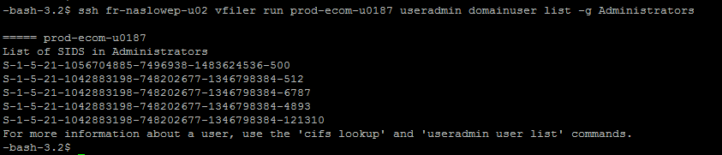

1. Create a Volume for the newly created CIFS Vfiler through WFA

Login into respective WFA and from Portal Menu (left side), select the “7M Logical Build” and select “TR Create Volume” button for making new volume.

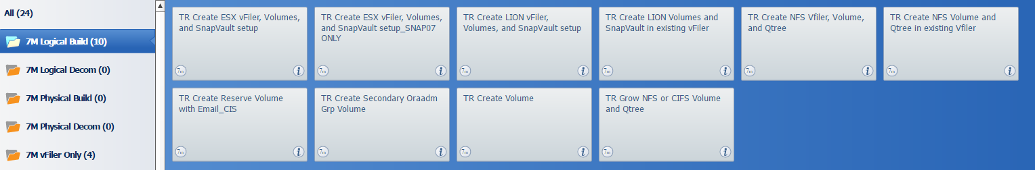

1. Input the volume name and size after selecting the aggregate your identified as part of the pre-requisites and Execute the workflow

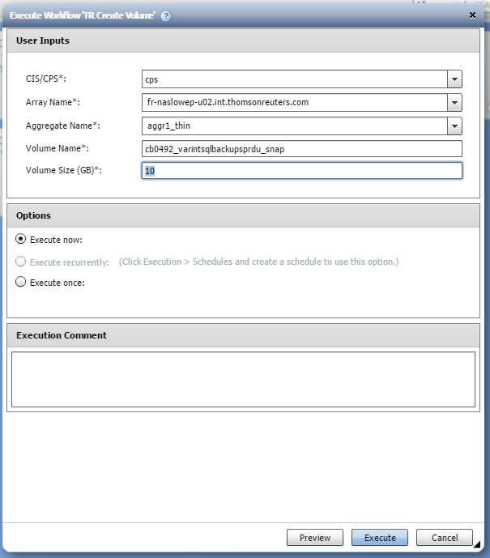

1. After executing the Volume created, cross-check the volume details and CIFS status through CLI.
   1. Check the volume details:

#ssh <filer_name> vfiler name <vfiler_name> df –h <volume_name>

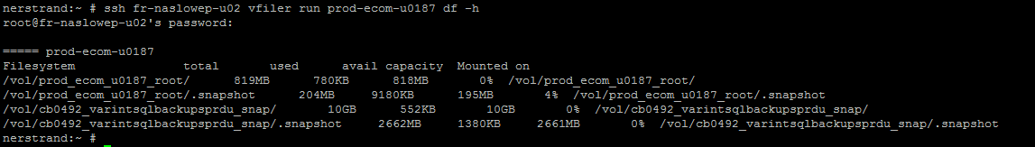

* 1. List the SIDs of the domain Admins:

ssh <filer_name> vfiler run <vfiler_name> useradmin domainuser list -g Administrators

* 1. List the local administrators:

ssh <filer_name> vfiler run <vfiler_name> useradmin group list Administrators -u

* 1. List the Local Users:

ssh <filer_name> vfiler run <vfiler_name> useradmin user list

* 1. List the local groups:

ssh <filer_name> vfiler run <vfiler_name> useradmin group list

* 1. List the CIFS shares:

ssh <filer_name> vfiler run <vfiler_name> cifs shares

* 1. List the CIFS domain details :

ssh <filer_name> vfiler run <vfiler_name> cifs domaininfo

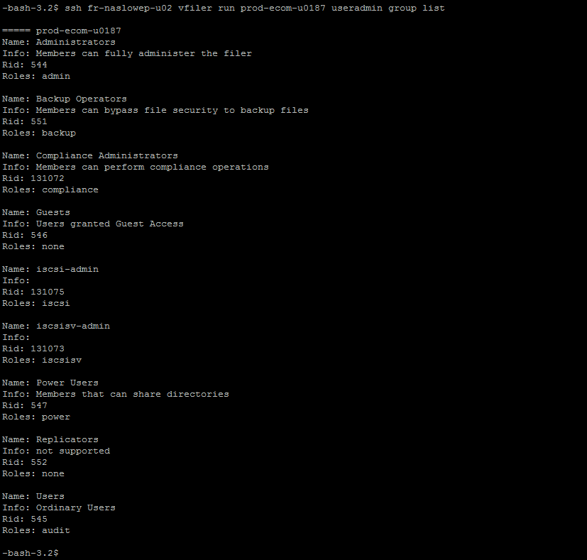

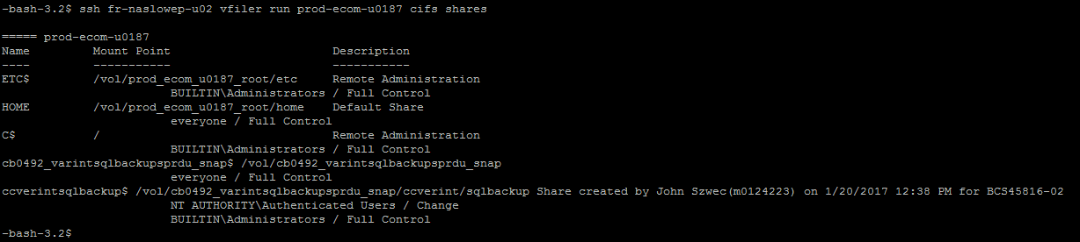

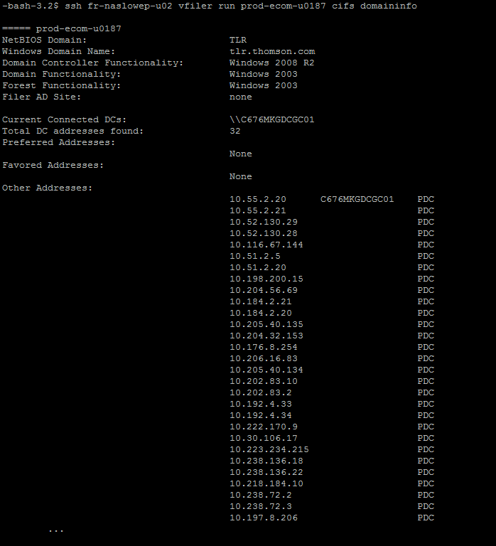

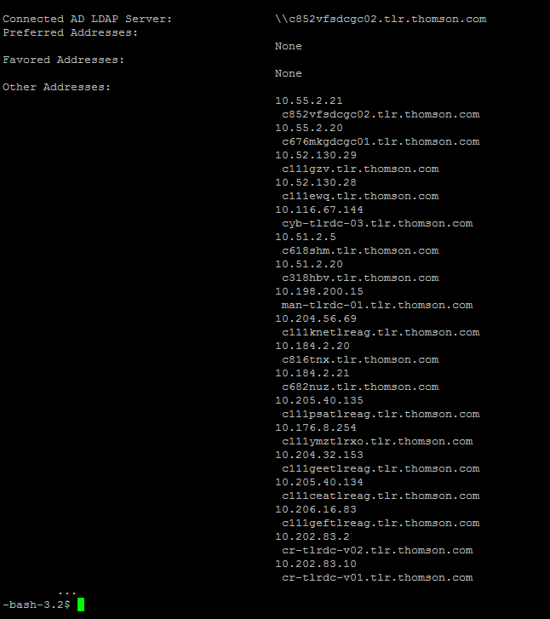

### Adding Space to existing 7-mode volume:

All space add provisioning requests should go through the standard delivery process. The only time storage support will add space to existing volume is for loaner and emergency space adds as outlined in section Emergency/Loaner Storage Provisioning

All 7-mode space adds should be completed through Service now Automation workflow as it takes into account utilization and overcommit checks.

*Submit a pre-approved CR as outlined below:*

1. Review the guidelines outlined in section Emergency/Loaner Storage Provisioning
2. If the request qualifies as an Emergency/Loaner request then raise CR in SM9 tool with following categories, select <Storage>

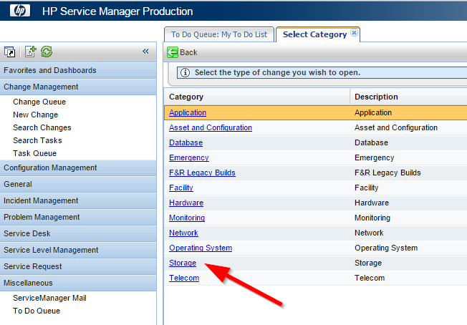

1. Then within the CR, select <Configuration> for the “Subcategory” section

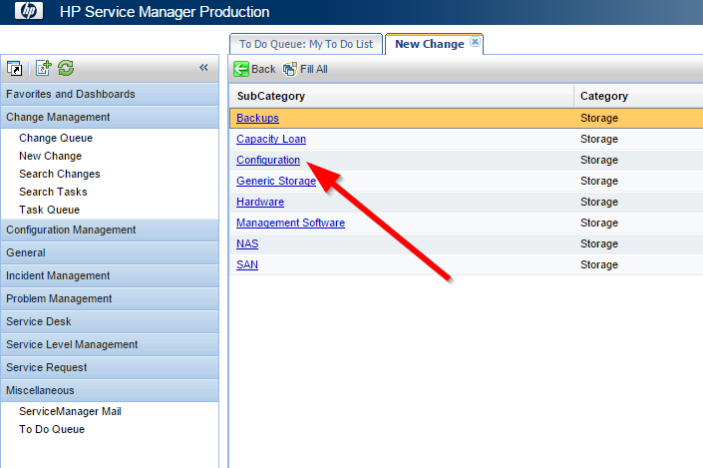

1. Then select <Storage Increase>

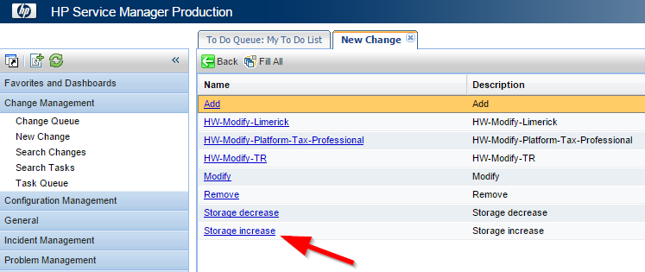

1. Fill in rest of CR with correct details related to the change and put in schedule to suit. Storage Add’s should typically be made outside of business hours. However if there is pending outage then the CR can be scheduled to start asap.
2. Once the CR is saved, associate the CR with the IM requesting the Storage Add/Decrease

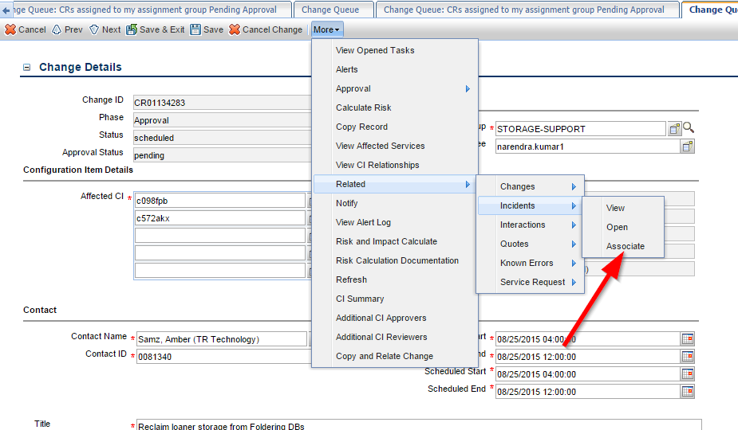

1. Next the CR needs to be approved before executing, this needs to be done by a storage-support peer.
2. Once approved, you are good to execute the CR. Once completed, close down CR as per normal standards (less than 5 hours after scheduled end to avoid violation).

*Step to increase the Storage*

Step 1: Check the utilization

**ssh <pfiler> vfiler run <vfiler> df -g <vol name>**

Step 2: Check how many qtrees are available for the volume

**ssh <pfiler> vfiler run <vfiler> qtree status <vol name>**

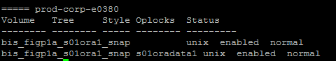

step 3: Check if the quotas are enabled for the given volume.

**ssh <pfiler> vfiler run <vfiler> quota status <vol name>**

**Ex:** if the quotas are off



If the quotas are on



**Note: if the quotas are off for the given volume proceed to step 11.**

Step 4: If Quotas is ON for the given volumes. Check quota report and validate the current utilization of the qtree (it will give in KB convert that in GB by dividing it with 1024)

**ssh <pfiler> vfiler run <vfiler> quota report | grep <<volume>>**

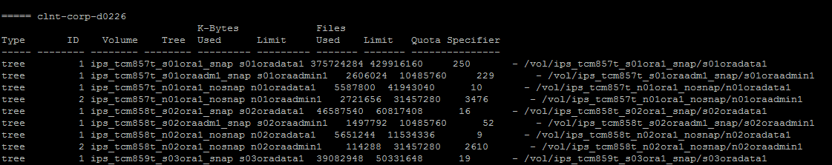

Step 5: Create a directory to mount the vfiler root volume (**etc directory)**

Step 6: mount the root volume the vfiler to the above created volume

**Sudo mount <<vfiler name>>:/etc <<mount directory>>**

Step 7: change the directory to the mount directory

# cd <<mount directory>>

Step 8: under this directory you will find quotas file (/etc/quotas)

Step 9: create a copy of the quota file and modify the quota size for the given volume/qtree.

#cp quotas quotas.<<ddmmyy>>

Step 10: Change the size of the quota as per the customer request using vi editor

Step 11: Set the vol size to the requested value via service now.

Go to the below link:

<https://thomsonreuters.service-now.com/dcis/req_spec.do?sysId=a3d8c70e905c1e0072752eaf361fedfasplitpage=com.glideapp.servicecatalog_cat_item_view>

Fill the below fields like Request type, vfiler name, volume name, current volume size,

As shown below

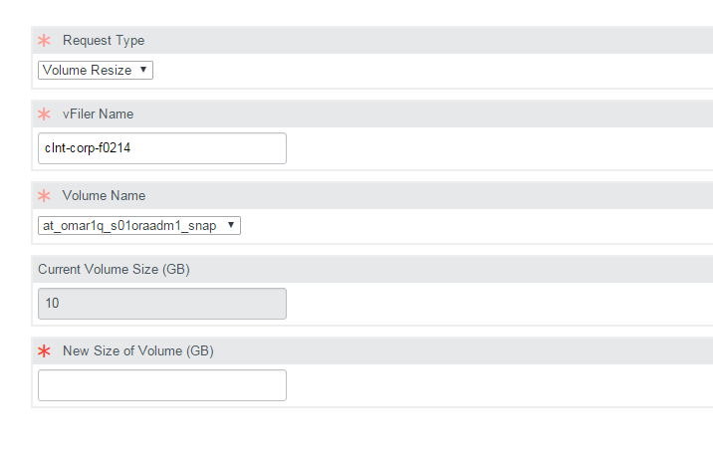

In the new size of volume field enter the new total size of the volume:

Ex: if the request is to grow the volume by 100GB and the current size is 50 GB. enter the new size of the volume as 150GB

Step 12: Resize the quota so that it will get updated

**ssh <pfiler> vfiler run <vfiler> quota resize <vol name>**

Step 13: After resizing the quota check the quota report to ensure the new size is reflected.

**ssh <pfiler> vfiler run <vfiler> quota report | grep <vol name>**

**NOTE**:

1. In-Case of any issue with Service Now, please follow the below manual process to grow the volume.
2. Please refer to Table 1&2 for snap and nosnap volume size calculations respectively.

**The following steps should be used only when there is an issue with Service Now:**

**Note: Aggregate should NOT exceed 200% overcommit and 75% full upon adding new provisioning. Upon provisioning, new storage aggregate utilization should be at ~65% and overcommit ~190%**

**. If this is an emergency request to mitigate the issue and the overcommit and utilization is above thresholds then please ensure the utilization does not go over 80% and create an Incident ticket to plan the thin mitigation.**

Step 1:check the current size of the volume.

**ssh <pfiler> vol size <vol name>**

step 2: Increase the volume to the new desired size.

**ssh <pfiler> vol size <vol name> <new size of the volume>**

Step 3: Resize the quota so that it will get updated

**ssh <pfiler> vfiler run <vfiler> quota resize <vol name>**

Step 4: After resizeing the quota check the quota report it will get updated there

**Calculation of new volume size for snap volume: (considering the growth request is for 50G)**

EX: To: add 50Gb Space to **snap** volume:

**Table 1:**

|  |  |  |  |
| --- | --- | --- | --- |
|  |  | Size | New Size |
| Vol Size | 80% | 128 | 178 |
| Snap Reserve | 20% | 32 | 45 |
| Total Vol Size | 100% | 160 | 223 |

EX: To add 50Gb Space to **nosnap** volume:

**Table 2:**

|  |  |  |  |
| --- | --- | --- | --- |
|  |  | Size | New Size |
| Vol Size | 100% | 128 | 178 |
| Snap Reserve | 0% | 0 | 0 |
| Total Vol size | 100% | 128 | 178 |

### Adding Exports to existing volumes in 7-mode

*Summary*

Typically, BU/Platforms team will raise SR to request an edit to the exports file for permissions to storage. A Change Request ticket will then need to be raised by Storage-Support Team in preparation for this change. The pre-approved change template in service now should be used to create the change with a task to Unix Support to mount the qtree/volume.

All exports changes should be performed after business hours only. Any change that needs to be done during business hours should be created as an EMERGENCY CHANGE.

**NOTE: PLEASE NOTE CROSS-SITE MOUNTS ARE NOT A STANDARD AND NOT ALLOWED. A storage volume/qtree located in Site A should not be exported to server located in different site/datacentre. Ex: Storage/volume in Eagan Site E should not be exported to Server in Eagan Site F or DTC etc.**

**If an exception is required then this should have BU Architecture approvals in place and should be attached to the change ticket.**

*Process to edit the Export file:*

Step 1: Identify the root volume of the vfiler to which exports needs to added.

CMD> ssh <Pfiler_name> vfiler status –r <vfiler_name> | grep etc



Step 2: Check which client has mount permission to mount the etc folder of vfiler root volume.

CMD> ssh <Pfiler_name> vfiler run <vfiler_name> exportfs –q <etc folder path in root volume>



Step 3: Login to any one of the above servers and create a folder in your home dir to mount the etc folder of vfiler root volume.

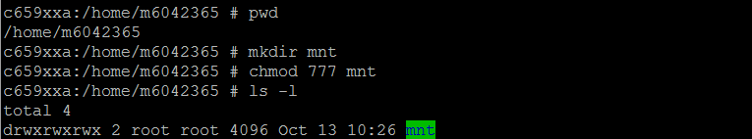

Step 4: Mount the etc folder of vfiler root.

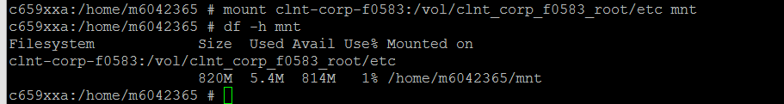

Step 5: cd to mnt folder and look for exports file.

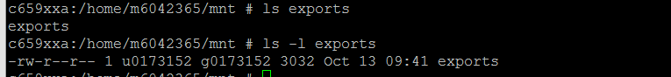

Step 6: Take the backup of exports file (name the backup file as exports_current date (exportfs_backup_ddMMMyyyy)



Step 7: Open the exports file in vi editor and add an entry for requested volume or qtree path along with the hosts that need requested access.

Please go through the following link for how to add entry in exports file. <https://library.netapp.com/ecmdocs/ECMP1196979/html/man5/na_exports.5.html>

Step 8: Issue the following command to export the added path in exports file.

CMD> ssh <Pfiler_name> vfiler run <vfiler_name> exportfs <exported volume or qtree path>



Step 9: Use the following command to check if the export was successful and the hosts have required permission.

CMD> ssh <Pfiler_name> vfiler run <vfiler_name> exportfs –c <IP of the host added in exports file> <exported volume or qtree path> <options(rw|ro|root)>

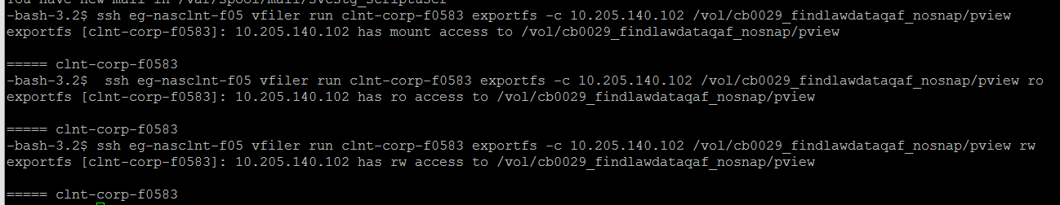

Step 10: Close the CR and update the SR.

## How to Provision Storage on c-DOT?

### Create a new c-DOT vserver:

All new vserver creation requests should go through the standard delivery process. Storage Support team should create a new vserver only under the below circumstances:

* Tech refresh migrations
* Thin mitigation
* Migrations due to Performance Issues

*Pre-requisites:*

Review and follow the guidelines as outlined here

*Steps to create a new vserver:*

1. Complete the prerequisites and IP request as documented.
2. Next, proceed to vserver creation using WFA. Note: **CLI should not be used.**

<http://167.68.250.87:27900/wfa/>   -- CIS

<http://167.68.246.65:27900/wfa/>    -- CPS

1. Login to the WFA using your MGMT\M-Account.



1. In the menu to the left, select “No Category” and uncheck the “7-Mode” box.
   1. Click the workflow titled “TR cDOT Create Vserver Only”.

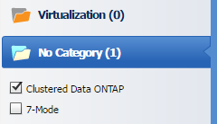 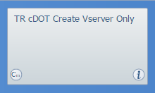

1. In the BCS Number box, enter the BCS Number or CR number
2. Next, select either CPS or CIS the drop-down menu.

Note: Although you are allowed to select either option, if the selection does not match the instance of WFA you are in (step 1), the vserver will not be created successfully.

1. In the “ClusterType*” box select the correct option for your vserver. Usually Primary.
2. Select the cluster for the new vserver. Then select the correct “Node Name”.
3. The aggregate name will auto populate.

Note: Sometimes it populates the incorrect aggregate. If this happens, choose a different node, and then choose the correct one. It will fix the aggregate name entry.

1. Enter the name assigned to the new vserver.
2. Click the dropdown menu for “Vserver Type” and select the type of vserver you are creating.

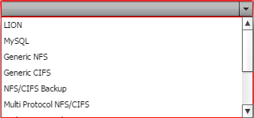

1. The “CIFS Server Domain” and “CIFS Server OU” will only be required if you selected “Generic CIFS” or “Multi Protocol NFS/CIFS”.

If you are migrating from an old vfiler, ssh to the source filer and run the following command: vfiler run <vfiler> cifs domaininfo, then choose the corresponding CIFS domain from the dropdown menu.

The “CIFS Server OU” will auto populate according to the domain selected.

1. For the “DNS Environment”, select one that corresponds with the cluster selected.

Choose the “int.thomsonreuters.com” option when available.

The DNS Domains/Servers will auto populate for you.

1. Next is the “Data Logical Interface Details” section:

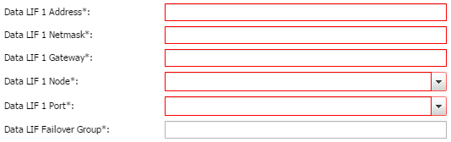

* 1. Fill in the Address, Netmask, and Gateway with the information given after requesting an IP for the new vserver.
  2. Enter the Failover group and then select the “Data LIF 1 Port” from the drop down.
  3. Check the “Data LIF 1 Node” for the correct node. Sometimes it does not update correctly.

1. Finally, check for any fields that updated incorrectly.

The common ones to change are “Node/Aggregate Name”, “LIF Node”, and “LIF Port”

1. Execute the workflow.

If there is an error, “clear reservations” for that job and check the “user input” tab for errors. The most common reasons for failure are the vserver name is already in use, or entries in the user inputs reverted to their default values.

If the Workflow failed after the first task completes, you may need to manually offline and delete the new vserver before attempting to create it again.

### NFS (LION Storage Provisioning) on c-DOT:

*Pre-requisites:*

Below pre-checks are required before starting a LION allocation:

* Review and follow the guidelines as outlined here
* Validate the vfiler details:

1. If this requires a new vfiler then, Complete the prerequisites and IP request as documented to obtain a vfiler name and (IP, DNS, Vlan) network details.
2. If the request is to add space to existing vfiler , make sure you have the vfiler details. **DO NOT COMBINE DIFFERENT BU VOLUMES in SAME VFILER.**

* Check if the request is for CIS or CPS environment.
* As per standards three volumes need to be created n01, s01 and s01oraadmin. check if all these 3 volumes are specified in the request with relevant qtrees.
* Check you have information about hosts that need the volume exported and their FQDN/domain names are correct.
* Check if retention period has been specified for the snap volumes.

At the time of writing this PCM the WFA workflow is still under testing. Follow the steps outlined in the document [here](https://theshare.thomsonreuters.com/sites/DCO_Storage/_layouts/WordViewer.aspx?id=/sites/DCO_Storage/Unified%20Storage%20DE%20Documents/NETAPP/Ontap%20CDOT%20Standards/Oracle%20on%20NetApp%20cDOT%20-%20Deployment%20Guidelines.docx&Source=https%3A%25). Please ensure all the steps outlined in this document are followed diligently.

### NFS (non-LION Storage Provisioning) on c-DOT:

<TBA in next release>

Review and follow the guidelines as outlined here

### ESX Storage Provisioning on c-DOT:

*Pre-requisites:*

Below pre-checks are required before starting a ESX allocation:

* Review and follow the guidelines as outlined here
* Complete the prerequisites and IP request as documented to obtain a vfiler name and (IP, DNS, Vlan) network details.
* Check if the request is for CIS or CPS environment.
* Check you have information about hosts that need the volume exported and their FQDN/domain names are correct.
* Check if retention period has been specified for the snap volumes.

*Steps to complete the ESX provisioning:*

1. Make sure you have read through the ESX deployment Standards.
2. Complete the prerequisites.
3. Next, proceed to vfiler creation using WFA. Note: **CLI should not be used.**

<http://167.68.250.87:27900/wfa/>   -- CIS

<http://167.68.246.65:27900/wfa/>    -- CPS

1. Login to the WFA as below. We have to use MGMT\M-Account to login to the WFA.
2. Select the below highlighted ICON to start creating the ESX vserver, volume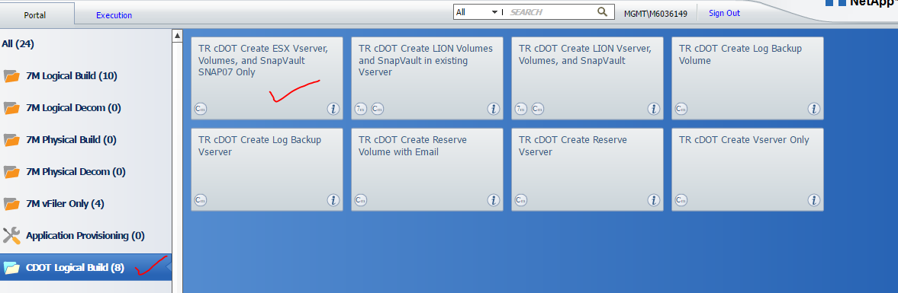

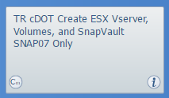

1. Provide BCS/ CR as well the email to get the workflow commands.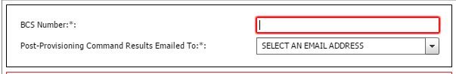
2. Input the Vserver Details:

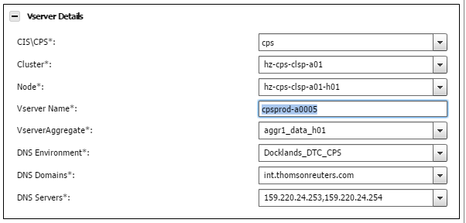

* *CIS/ CPS:* Please select the respected environment in which you are creating the Vserver.
* *Cluster:* Select the cluster where we creating the Vserver.
* *Node:* Select the node in which you are creating the Vserver.
* *Vserver Name:* Input the Vserver name which you are creating.
* *Vserver Aggregate:* Automatically selected based on the Node.
* *DNS Environment:* Select the DNS environment based on the DC location.DO NOT USE A DIFFERENT SITE/MODULE DNS.
* *DNS Domain & DNS server:* Once the DNS environment is selected it will automatically populate the DNS domain and DNS server.

1. Enter the Data Logical Interface details:

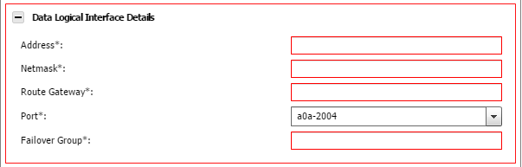

* *Address, Netmask & Route gateway:* Input the details based on the Banana IP request.
* *Port:* This will be theVlan of the Vserver which you are creating.
* *Failover Group:* Input the Failover group as shown below

Login to the cluster:



This will list all failover groups. we have to select the failovergroup which points to the port

Ex: If the port is a0a-2051 the failover group will be data-2051

1. Next Input the Storage Details:

* *Aggregate:* It will be selected by default when you select the node during the Vserver details*.*
* *Volume CB Number:* Update the charge back number.
* *Enter the volume size:* Select 07, 14, 45 and nosnap volumes and provide the sizes of the volume.
  1. *If the BU requested for 07 snap volumes mean checking snap07 only and uncheck the remaining ones.*
* *Hosts with Read/Write and Root Access:* Enter comma (,) separated FQDN of the hosts that need access
* *Enable thin provisioning:* Enable thin provisioning.
* *Primary Dedupe hours:* It should be always be non-business hours i.e. 22:00 to 03:00 irrespective of time zones.

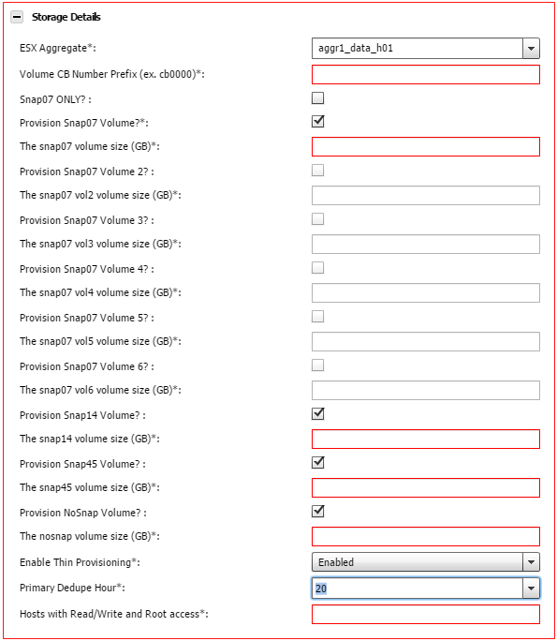

1. Next Enter the Snapvault details:

* *Snapvault Backup Cluster:* We have to provide the backup cluster for Snapvault configuration. Before that login to the cluster and verify backup clusters connected to the source cluster.

Ex: See example below

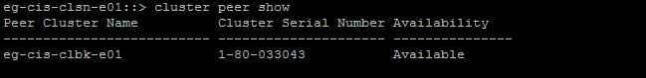

* *Snapvault Backup Vserver:* Select the vserver in the cluster where we are configuring the backup. Select a vserver that is on the same vlan as the source vserver.
* *Snapvault Backup Node & Snapvault Backup:* Aggregate will be populated automatically based on the previous selection.
* *Snapvault transfer hour:* It should be always in non-business hours i.e., 22:00 to 03:00 irrespective of time zones.

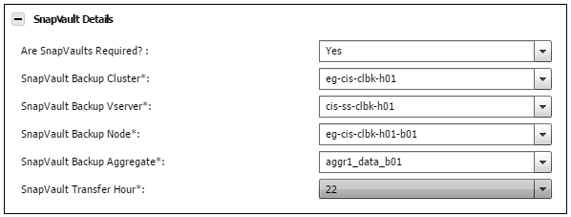

1. Execute the Workflow:

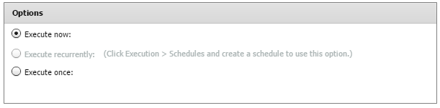

If there is an error, “clear reservations” for that job and check the “user input” tab for errors. The most common reasons for failure are the vfiler/volume name is already in use, or entries in the user inputs reverted to their default values.

If the Workflow failed after the first task completes, you may need to manually offline and delete the new vserver before attempting to create it again.

1. Complete Post checks
2. Verify the Vserver which was created.



1. Verify the volumes created under the Vserver:

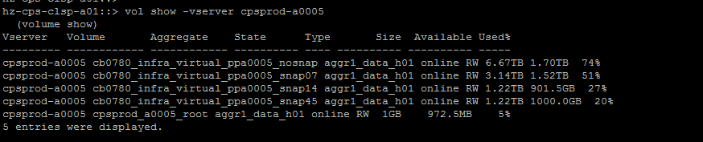

1. Verify the volume settings on all volumes that were created:



Things need to check is

* Export Policy

Verify all the servers are exported to default policy. Repeat this for all the volumes which is created now.



Verify all the servers are exported to policy. Repeat this for all the volumes which is created now.



* Verify Junction Path is created correctly.The above command will give all the major characteristics of the volume. Per standards the volume name, export-policy and the junction path should be same for the volume. If we find the Junction path is not configured, please find steps below to configure the junction path:
  + Mount the volume with Junction path

volume mount -vserver <vserver> -volume <vserver> -junction-path /<vserver>

* + Verify the junction path now.
* QoS Policy Group Name

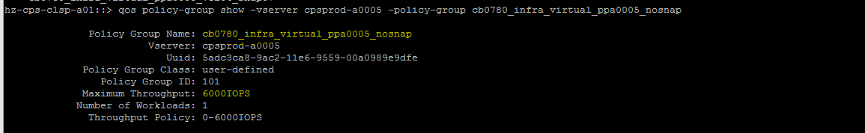

By default, QOS is set to 6000IOPs for shared filers for new build requests. For tech refresh, thin mitigation migrations etc. from 7-mode check the source peak IOPS and set QOS to 6000IOPS if source IOPS were lower. If the source IOPS was higher than 6k review with D&E and set to the peak IOPS.

For any dedicated cluster QOS should be set to INF.



1. Verify the Quota. It should be off for the ESX volumes

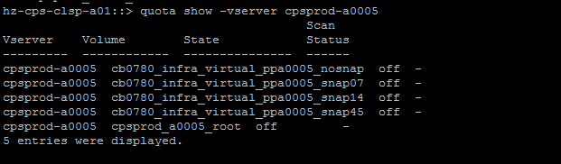

1. Verify the Dedupe status and if it has the dedup policy assigned:

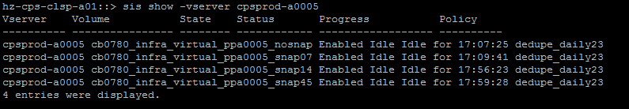

1. Verify the snapshot policy as per the inputs.

Note: For nosnap volume the default policy should be none

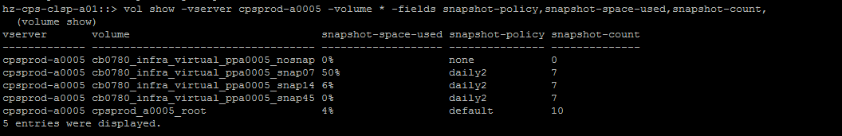

1. Verify the Snapvault status:
   * Identify the destination path from the source cluster:



* + Cluster peer show to identify the backup cluster:

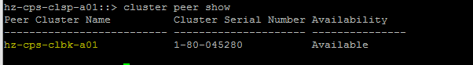

* + Login to the backup cluster. Verify the SV status

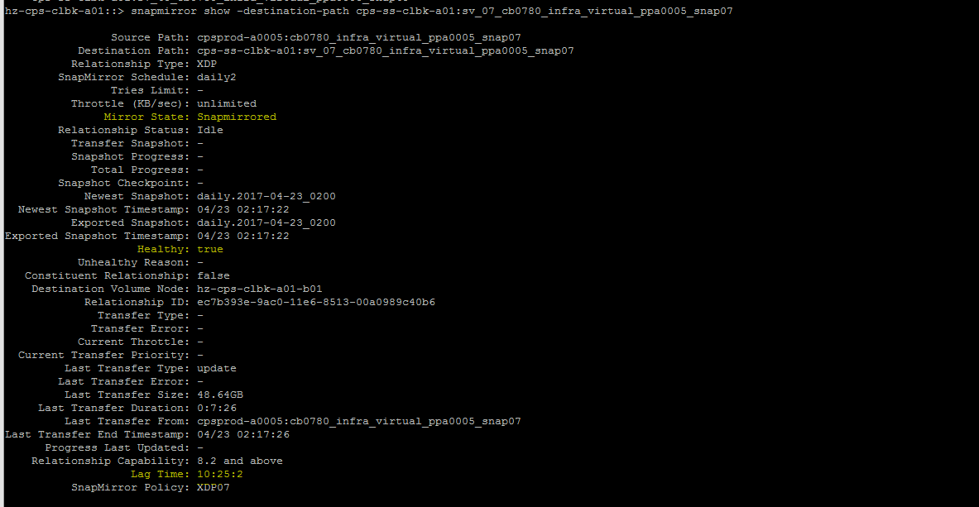

### MySQL storage provisioning on c-DOT:

*Pre-requisites:*

Review and follow the guidelines as outlined here

At the time of writing this PCM the WFA workflow is still under testing. Follow the steps outlined in the document [here](https://theshare.thomsonreuters.com/sites/DCO_Storage/_layouts/WordViewer.aspx?id=/sites/DCO_Storage/Unified%20Storage%20DE%20Documents/NETAPP/Ontap%20CDOT%20Standards/CDOT-MySQL_Deployment_Guide_v6.doc&Source=https%3A%2F%2Ftheshare%2Ethomsonreute). Please ensure all the steps outlined in this document are followed diligently.

### ISCSI storage provisioning for WISP on c-DOT:

*Pre-requisites:*

Review and follow the guidelines as outlined here

At the time of writing this PCM the WFA workflow for WISP is still under testing. Follow the steps outlined in section 3 and 4 of the document [here](https://theshare.thomsonreuters.com/sites/DCO_Storage/_layouts/WordViewer.aspx?id=/sites/DCO_Storage/Unified%20Storage%20DE%20Documents/NETAPP/Ontap%20CDOT%20Standards/WIP%20and%20WISP%20Procedures%20on%20cDOT_v1%209%20(2).docx&Source=https%3A%2F%25). Please ensure all the steps outlined in this document are followed diligently.

**Note: Please note WISP on c-DOT is still under SI for new version of SMSQL. Any new deployments or migration of WISP to c-DOT should be signed off by the DBA team.**

Pay extra caution to the retention the backup filer as the DBA team takes multiple snapshots per day.

Complete the QA checklist to validate all configuration steps were completed.

### Multiprotocol Storage Provisioning on c-DOT:

*Pre-requisites:*

Review and follow the guidelines as outlined here

Follow the steps outlined in the document [here](https://theshare.thomsonreuters.com/sites/DCO_Storage/_layouts/WordViewer.aspx?id=/sites/DCO_Storage/Unified%20Storage%20DE%20Documents/NETAPP/Ontap%20CDOT%20Standards/Multi-Protocol%20cDOT.docx&Source=https%3A%2F%2Ftheshare%2Ethomsonreuters%2Ecom). Please ensure all the steps outlined in this document are followed diligently.

### How to deploy NFS4 on c-DOT for MQ:

*Pre-requisites:*

Review and follow the guidelines as outlined here

There is no WFA workflow for NFS4 deployment. For the steps for creating a vserver with NFS4 refer [here](https://theshare.thomsonreuters.com/sites/DCO_Storage/_layouts/WordViewer.aspx?id=/sites/DCO_Storage/Unified%20Storage%20DE%20Documents/NETAPP/Ontap%20CDOT%20Standards/NFSv4%20cDOT.docx&Source=https%3A%2F%2Ftheshare%2Ethomsonreuters%2Ecom%2Fsites%25). Please ensure all the steps outlined in this document are followed diligently.

### Add Hosts to Exports on c-DOT:

*Summary*

Typically, BU/Platforms team will raise SR to request an edit to the exports file for permissions to storage. A Change Request ticket will then need to be raised by Storage-Support Team in preparation for this change. The pre-approved change template in service now should be used to create the change with a task to Unix Support to mount the qtree/volume.

All exports changes should be performed after business hours only. Any change that needs to be done during business hours should be created as an EMERGENCY CHANGE.

**NOTE: PLEASE NOTE CROSS-SITE MOUNTS ARE NOT A STANDARD AND NOT ALLOWED. A storage volume/qtree located in Site A should not be exported to server located in different site/datacentre. Ex: Storage/volume in Eagan Site E should not be exported to Server in Eagan Site F or DTC etc.**

**If an exception is required then this should have BU Architecture approvals in place and should be attached to the change ticket.**

*Steps to update exports on c-DOT:*

1. Verify the current export-policy that is assigned to the volume as shown below and make a note of policy that shows in output.

Command**:** *volume show -vserver <vserver_name> -volume cb0669_trc_saneeppe_snap -fields policy*



**Note:** The volume policy name should be same as volume name except for arch volumes.

1. Verify whether the required host is already added in default policy of vserver and volume export-policy.

Comand to check whether the host entry is added in default policy of vserver:

*export-policy rule show -vserver <vserver_name> -policyname default -clientmatch *<host name>\**



Command to check whether the host entry is added in export-policy of volume:

*export-policy rule show -vserver <vserver_name> -policyname <volume export-policy name> -clientmatch *<host name>\**



1. Add the host if it is not already in default or volume export-policy. Add the host name in default policy with ready-only authentication of sys, read-write as never and superuser as none.

Command**:** *export-policy rule create -vserver <vserver_name> -policyname default -rorule sys -rwrule never -superuser none -protocol any -clientmatch <host name with FQDN>*

Add the host name in volume export-policy with read/read-write/supersuer security type of ‘sys’. This provides read-write access to the host.

Command: *export-policy rule create -vserver <vserver_name> -policyname <volume policy name> -rorule sys -rwrule sys -superuser sys -protocol any -clientmatch <host name with FQDN>*

**Note:** Host name should be added in both default policy of vserver as well as volume policy.

1. Verify the access of the host that is given as shown below:

Command**:***export-policy check-access -vserver <vserver_name> -volume <volume_name> -qtree <qtree_name> -client-ip <host ip> -authentication-method sys -protocol nfs3 -access-type read-write*



**Note:** If there is no qtree in the volume we can remove ‘-qtree’ section to verify access at volume level.

1. Close the CR and update the SR/IM.